

**DANDELION**

Report #2 – Software Requirement Specification

|  |  |  |
| --- | --- | --- |
| **Dandelion** | | |
| **Group Members** | Vũ Công Chính | SE02585 |
| Lưu Ngọc Mạnh | SE02619 |
| Nguyễn Minh Huy | SE02723 |
| Dương Đức Anh | SE02700 |
| Vũ Ngọc Trung | SE02967 |
| Cao Thị Phương Mai | SE02908 |
| **Supervisor** | Mr. Nguyễn Văn Sang | |
| **Project code** | DDL | |

**- Hanoi, 09/2015 -**

# SIGNATURE PAGE

AUTHOR: Cao Thị Phương Mai 01/10/2015

Team member

REVIEWERS: Lưu Ngọc Mạnh /10/2015

Project Manager

APPROVAL: Nguyễn Văn Sang --/--/--15

Supervisor

Record of change

*A - Added M - Modified D – Deleted

|  |  |  |  |  |  |
| --- | --- | --- | --- | --- | --- |
| Effective Date | Changed Item | A,M,D | Change Description | Reason for Change | Rev. Number |
| 01/10/2015 | Create Software Requirements Specifications | A | First version | Create Software Requirements Specifications | 1.0 |
| 02/10/2015 | Modify Business rule, Non-Functional specification | M | First version | Modify Software Requirements Specifications | 1.1 |
|  |  |  |  |  |  |
|  |  |  |  |  |  |
|  |  |  |  |  |  |
|  |  |  |  |  |  |
|  |  |  |  |  |  |
|  |  |  |  |  |  |
|  |  |  |  |  |  |
|  |  |  |  |  |  |
|  |  |  |  |  |  |
|  |  |  |  |  |  |
|  |  |  |  |  |  |
|  |  |  |  |  |  |
|  |  |  |  |  |  |
|  |  |  |  |  |  |
|  |  |  |  |  |  |
|  |  |  |  |  |  |
|  |  |  |  |  |  |
|  |  |  |  |  |  |
|  |  |  |  |  |  |
|  |  |  |  |  |  |
|  |  |  |  |  |  |
|  |  |  |  |  |  |

Table of Contents

**1.** **INTRODUCTION** 5

1.1. Purpose 5

1.2. Definitions and Acronyms 5

1.3. System Purpose 6

**2.** **OVERALL DESCRIPTION** 7

2.1. System overview 7

2.2. Use Case Diagram 7

2.3. Product Features 8

2.3.1. User Characteristics 11

2.3.2. User Documentation 12

2.3.3. Assumption 12

2.4. Entity Relation Model 12

2.4.1. Entity-Relationship Diagram 12

2.4.2. Entity Detail 12

**3.** **FUNCTIONAL SPECIFICATION** 15

3.1. Appendix 15

3.2. Business Rules 15

3.3. Use Cases 17

3.3.1. Common Module 17

3.3.2. Suggest Module 22

3.3.3. Social Module 25

3.3.4. Account Management Module 71

3.3.4.1. Login 72

3.3.4.2. UC049-Logout 73

3.3.4.3. UC050-Register 74

3.3.4.4. UC051-Edit profile 75

3.3.4.5. UC052-Forgot password 76

3.3.5. Admin Module 78

3.3.5.1. UC053-Lock user’s account 78

3.3.5.2. UC054-Unlock user’s account 79

3.3.5.3. UC055-Send warning 80

3.3.5.4. UC056-Review user 81

3.3.5.5. UC057-Review post 82

3.3.5.6. UC058-Delete user’s post 83

3.3.5.7. UC059-Reply question 84

**4.** **NON-FUNCTIONAL SPECIFICATION** 85

Reliability 85

Performance Requirements 85

User Interface 85

Maintainability 85

Usability 86

Security Requirements 86

Hardware/Software Requirements 86

# **INTRODUCTION**

## Purpose

This document is created as the introduction for project Dandelion– our Capstone Project at FPT University. In this document, we provide the describing of general requirement and non-functional requirements. These requirements will assure that the system will correctly and reliably perform its intended functionality. This specification will provide general, as well as specific requirements to be used in the design, testing and validation of the system. It is intended for both stakeholders and the project team of the system.

## Definitions and Acronyms

|  |  |  |
| --- | --- | --- |
| **Acronym** | **Definition** | **Note** |
| DDL | Dandelion system |  |
| SRS | Software Requirements Specifications |  |
| Guest | DDL’s user who did not register |  |
| Registered | DDL’s user who registered |  |
| Admin | DDL’s administrator |  |
| User | DDL’s user |  |

Table 2-1: Definition and Acronyms

## System Purpose

Nowadays people have a lot of idea to make things better. But many of people are short of funds to raise their idea. However, many thanks for internet they can easy to show these ideas to everyone.   
Our project – Dandelion is a major platform for crowd funding. Anybody could launch a project on Dandelion as long as it follows our rules. We believe that creative projects making a better world, and we’re thrilled to help support new ones. Building a community of backers around an idea is an amazing way to make something new.

# **OVERALL DESCRIPTION**

## System overview

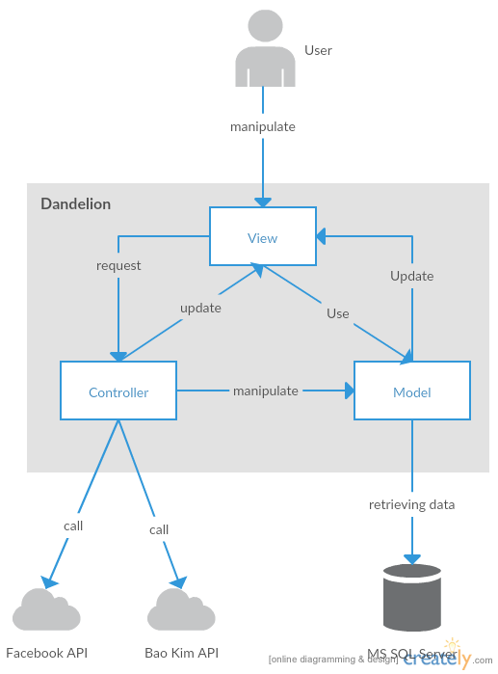

Figure 2-1: System Overview

## Use Case Diagram

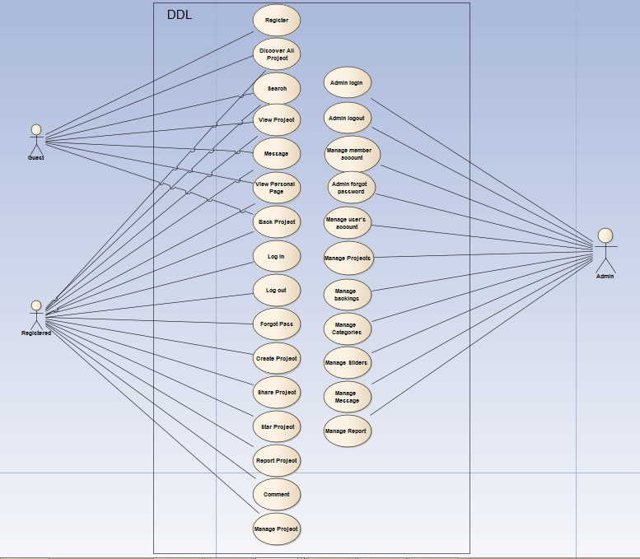

Figure 2-2: Use case diagram of DDL system

## Product Features

|  |  |  |  |
| --- | --- | --- | --- |
| UC No. | Group Of Functions | Function | Glossary |
| Guest/Registered | | | |
|  | Common | Discover all project |  |
|  | Search project |  |
|  | Back project |  |
|  | View project | View campaign |  |
|  | View update |  |
|  | View comments |  |
|  | View schedule |  |
|  | View Link Backers |  |
|  | Message | Search message |  |
|  | Send message |  |
|  | Delete message |  |
|  | View Personal page | View backed |  |
|  | View created |  |
|  | View starred |  |
|  | Public profile |  |
|  | Edit profile |  |
|  | Change password |  |
| Guest | | | |
|  | Common | Register |  |
| Registered | | | |
|  | Common | Login |  |
|  | Logout |  |
|  | Forgot password |  |
|  | Create project |  |
|  | Share project |  |
|  | Star project |  |
|  | Report project |  |
|  | Comment | View list comment |  |
|  | Post comment |  |
|  | Edit comment |  |
|  | Delete comment |  |
|  | Manage Project | Add update project |  |
|  | Edit project |  |
|  | View list backer |  |
| Administrator | | | |
|  | Common | Admin login |  |
|  | Admin logout |  |
|  | Admin forgot password |  |
|  | Manage user's account | View list user |  |
|  | View user profile |  |
|  | Active user's account |  |
|  | Inactive user's account |  |
|  | Search user's account |  |
|  | Export list users |  |
|  | View dashboard |  |
|  | Manage projects | View list projects |  |
|  | Search project |  |
|  | View(review) project |  |
|  | Approve project |  |
|  | Suspend project |  |
|  | Export list projects |  |
|  | View dashboard |  |
|  | Manage backings | View list backing |  |
|  | Search backing |  |
|  | View backing's information |  |
|  | Export list backings |  |
|  | View dashboard |  |
|  | Manage Categories | View list categories |  |
|  | Search category |  |
|  | Active category |  |
|  | Inactive category |  |
|  | Add new category |  |
|  | Edit category |  |
|  | Export list categories |  |
|  | Manage Sliders | View list slider |  |
|  | Active slider |  |
|  | Inactive slider |  |
|  | Add new slider |  |
|  | Preview slider |  |
|  | Edit slider |  |
|  | Delete slider |  |
|  | Manage Message | View list messages |  |
|  | Search message |  |
|  | Send message |  |
|  | View message |  |
|  | Delete message |  |
|  | Manage Report | View report list |  |
|  | View report detail |  |
|  | Change report's status |  |

Table 2-2: List of use case diagram

### User Characteristics

DDL website towards to anyone wants to launch a project on Dandelion as long as it follows our rules. Project creators set a funding goal and deadline. If people like a project, they can pledge money to make it happen. Backers are supporting projects to help them come to life, not to profit financially. Instead, project creators offer rewards to thank backers for their support. DDL has three objective users:

* **Guest:** Users did not register, they can use some function like Register, Discover project, Search, etc...
* Registered: Users have account on DDL, they can use almost functions of DDL for user like Login, Logout, Create, Manage project, Comment, Report, etc…
* **Administrator:** They can use all functions of normal member and have an Administrator control panel to manage all information, project and configuration of DDL.

### User Documentation

|  |  |
| --- | --- |
| **Name** | **Description** |
| User Guide | Provide detailed explanation about the system, screens and guide users how to use all features of DDL. |

Table 2-3: User Documentation

### Assumption

* Receive the guidance and good support of teacher.
* No one of member got sick in the software development process.
* In the development process, no device got fail.
* Every report, task meets the deadline.
* Team member do not conflict in the work process.

## Entity Relation Model

### Entity-Relationship Diagram

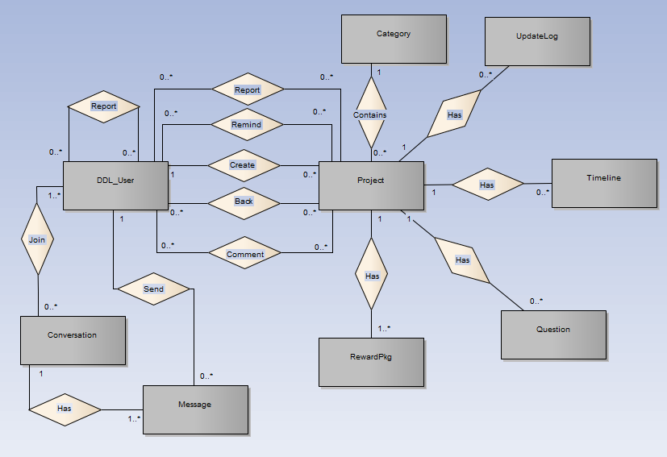

**Figure 2-3:** Entity Relationship Diagram

### Entity Detail

#### DDL_User

|  |  |  |  |  |
| --- | --- | --- | --- | --- |
| No | Attribute | Type | Mandatory | Description |
|  | UserID | Number | Y | User’s ID |
|  | UserName | String | Y | User’s name |
|  | Password | String | Y | User’s password |
|  | IsActive | Boolean | Y | User’s active status (inactive, active) |
|  | CreatedDate | Date | Y | User’s created date |
|  | LoginType | Number | Y | User’s created type includes: normal, Facebook or both |
|  | LastLogin | Date | Y | User’s last login |
|  | UserType | Number | Y | User’s type (admin or normal user) |
|  | IsVerify | Boolean | Y | User’ email verify status |

Table 2-4: DDL-User

#### Project

|  |  |  |  |  |
| --- | --- | --- | --- | --- |
| No | Attribute | Type | Mandatory | Description |
|  | ProjectID | Number | Y | Project’s ID |
|  | ProjectCode | String | Y | Project’s code with fixed format |
|  | CategoryID | Number | Y | Project’s category |
|  | UserID | Number | Y | Project’s UserID who created project |
|  | ProjectTitle | String | Y | Project’s title |
|  | Risk | String | Y | Project’s risk |
|  | ImageLink | String | Y | Project’s image link |
|  | SubDescription | String | Y | Project’s sub description |
|  | Location | String | Y | Project’s location created |
|  | IsExpired | Boolean | Y | Is Project’s expired |
|  | CurrentFunded | Number | Y | Project’s funded status |
|  | IsFunded | Boolean | Y | Is Project’s funded |
|  | CreatedDate | Date | Y | Project’s created date |
|  | ExpiredDate | Date | Y | Project’s expired date |
|  | FundingGoal | Number | Y | Project’s funding goal |
|  | Description | String | Y | Project’s description |
|  | LinkVideo | String | Y | Project’s video link |
|  | Story | String | Y | Project’s story |
|  | PopularPoint | Number | Y | Project’s popular point |
|  | Status | Number | Y | Project’s status ( draft, pending, approved, suspended) |

Table 2-5: Project

#### Category

|  |  |  |  |  |
| --- | --- | --- | --- | --- |
| No | Attribute | Type | Mandatory | Description |
| 1. 1 | CategoryID | Number | Y | Category’s ID |
| 1. 2 | Name | String | Y | Category’s name |
| 1. 3 | IsActive | Boolean | Y | Category’s active status |
|  | Description | String | Y | Category’s description |

Table 2-6: Category

#### UpdateLog table

|  |  |  |  |  |
| --- | --- | --- | --- | --- |
| No | Attribute | Type | Mandatory | Description |
| 1. 1 | UpdateID | Number | Y | Update’s ID |
| 1. 2 | ProjectID | Number | Y | Update’s project id |
| 1. 3 | Title | String | Y | Update’s title |
|  | Description | String | Y | Update’s description |

Table 2-7: UpdateLog table

#### Timeline table

|  |  |  |  |  |
| --- | --- | --- | --- | --- |
| No | Attribute | Type | Mandatory | Description |
| 1. 1 | TimelineID | Number | Y | Timeline’s ID |
| 1. 2 | ProjectID | Number | Y | Timeline’s project id |
| 1. 3 | Title | String | Y | Timeline’s title |
|  | Description | String | Y | Timeline’s description |
|  | DueDate | Date | Y | Timeline’s due date |

Table 2-8: Timeline table

#### Question table

|  |  |  |  |  |
| --- | --- | --- | --- | --- |
| No | Attribute | Type | Mandatory | Description |
| 1. 1 | QuestionID | Number | Y | Question and answer’s ID |
| 1. 2 | ProjectID | Number | Y | Question and answer’s project id |
| 1. 3 | Question | String | Y | Question and answer’s question |
|  | Answer | String | Y | Question and answer’s answer |
|  | CreatedDate | Date | Y | Question and answer’s created date |

Table 2-9: Caption table

#### Reward package table

|  |  |  |  |  |
| --- | --- | --- | --- | --- |
| No | Attribute | Type | Mandatory | Description |
| 1. 1 | RewardID | Number | Y | Reward’s ID |
| 1. 2 | ProjectID | Number | Y | Reward’s project id |
| 1. 3 | LimitedQuantity | String | Y | Reward’s limited quantity |
|  | Type | Number | Y | Reward’s type |
|  | Description | String | Y | Reward’s description |
|  | EstimatedDeliveryDate | Date | Y | Reward’s estimated delivery date |
|  | IsHide | Boolean | Y | Is Reward hide |

Table 1-10: Reward package table

#### Message table

|  |  |  |  |  |
| --- | --- | --- | --- | --- |
| No | Attribute | Type | Mandatory | Description |
| 1. 1 | MessageID | Number | Y | Message’s ID |
| 1. 2 | ConversationID | Number | Y | Message’s conversation id |
| 1. 3 | UserID | Number | Y | Message’s user id |
|  | MessageContent | String | Y | Message’s content |
|  | SentTime | Date | Y | Message’s sent time |

Table 2-11: Message table

#### Conversation table

|  |  |  |  |  |
| --- | --- | --- | --- | --- |
| No | Attribute | Type | Mandatory | Description |
|  | ConversationID | Number | Y | Conversation’s ID |
|  | CreatorID | Number | Y | Conversation’s creator id |
|  | ReceiverID | Number | Y | Conversation’s receiver |
|  | Subject | String | Y | Conversation’s subject |
|  | CreatedDate | Date | Y | Conversation’s created date |
|  | UpdatedDate | Date | Y | Conversation’s update date |
|  | DeleteStatus | Number | Y | Conversation’s user delete status |
|  | ViewStatus | Number | Y | Conversation’s user view status |

Table 2-13: Conversation table

# **FUNCTIONAL SPECIFICATION**

## Business Rules

|  |  |
| --- | --- |
| **No** | **Description** |
|  | Search textbox cannot be empty |
|  | Content is limited to 1000 characters |
|  | Chat box cannot be empty |
|  | Subject is limited to 1000 characters |
|  | Name cannot be empty |
|  | If user accesses to nonexistent page, DDL displays error message “Page not found” |
|  | Email must content characters ‘@’ and ‘.’ |
|  | Date of birth must be chosen |
|  | Displayed date is mm/dd/yyyy format |
|  | Date time input format is datetime |
|  | Number is rounded to 2 decimal number |
|  | Unit of money is VND |
|  | Displayed money is rounded to 2 decimal number |
|  | Allowed file extension: .jpg, .png, .bmp |
|  | File size is limited to 100 MB |
|  | Guest could back project without login |
|  | Message displayed like a gmail format |

Table 2-14: Business rules

## Use Cases

### Guest/ Registered Group Function

#### Common Module

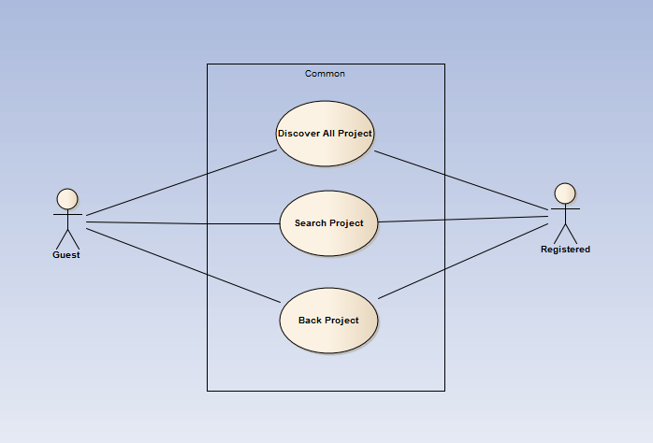

Figure 1-4: Common use case

##### UC001-Discover

|  |  |  |  |  |
| --- | --- | --- | --- | --- |
| **Use Case ID** | | UC001 | **Version** | 1.1 |
| **Use Case Name** | | Discover list of all project | | |
| **Created by:** | | AnhDD | **Date Created:** | 24/09/2015 |
| **Primary Actor** | | Guest & Registered user | **Secondary Actor** |  |
| **Description:** | | This function allows user to show all existing project stored on DDL | | |
| **Preconditions:** | | 1. DDL website is available 2. User browsed DDL website | | |
| **Trigger:** | | User click Discover | | |
| **Post conditions:** | | List all existing project will be displayed in the Discover screen | | |
| **Normal Flow** | | | | |
| **Step** | **Actor** | **Action** | | |
| 1 | User | Click Discover | | |
| 2 | DDL | List all existing project | | |
| **Alternative Flows:** | | | | |
| **AT1** | At step 1 in the main flows, if user click other hyperlinks or buttons | | | |
| **Step** | **Actor** | **Action** | | |
| 1.1 | DDL | Redirects user to chosen hyperlink or button | | |
|  | | | | |
| **Exceptions: N/A** | | | | |
| **Priority** | | High | | |
| **Frequency of Use:** | | High | | |
| **Business Rules:** | | B1 | | |
| **Other Information:** | | N/A | | |

##### UC002-Search Project

|  |  |  |  |  |
| --- | --- | --- | --- | --- |
| **Use Case ID** | | UC001 | **Version** | 1.1 |
| **Use Case Name** | | Search project | | |
| **Created by:** | | AnhDD | **Date Created:** | 24/09/2015 |
| **Primary Actor** | | Guest & Registered user | **Secondary Actor** |  |
| **Description:** | | This function allows user to search existing information about project stored on DDL by name | | |
| **Preconditions:** | | 1. DDL website is available 2. User browsed DDL website | | |
| **Trigger:** | | User enters search phrase and click Search or press Enter | | |
| **Post conditions:** | | List all results that matched with the keyword user enters will be displayed in the Search Details screen | | |
| **Normal Flow** | | | | |
| **Step** | **Actor** | **Action** | | |
| 1 | User | Enter search phrase to text box | | |
| 2 | User | Click Search or press Enter | | |
| 3 | DDL | List all results that matched with the keyword user entered | | |
| **Alternative Flows:** | | | | |
| **AT1** | At step 2 in the main flows, if user click other hyperlinks or buttons | | | |
| **Step** | **Actor** | **Action** | | |
| 2.1 | DDL | Redirects user to chosen hyperlink or button | | |
|  | | | | |
| **Exceptions: N/A** | | | | |
| **Priority** | | High | | |
| **Frequency of Use:** | | High | | |
| **Business Rules:** | | B1 | | |
| **Other Information:** | | N/A | | |

##### UC003- Back Project

|  |  |  |  |  |
| --- | --- | --- | --- | --- |
| **Use Case ID** | | UC003 | **Version** | 1.1 |
| **Use Case Name** | | Back project | | |
| **Created by:** | | AnhDD | **Date Created:** | 24/09/2015 |
| **Primary Actor** | | Registered user | **Secondary Actor** |  |
| **Description:** | | This function allows user to back a project | | |
| **Preconditions:** | | 1.DDL website is available  2.User browsed DDL website  3.User logged in to system  4.User are on project information page | | |
| **Trigger:** | | User click on button back | | |
| **Post conditions:** | | Back a project page is displayed | | |
| **Normal Flow** | | | | |
| **Step** | **Actor** | **Action** | | |
| 1 | User | Choose a project | | |
| 2 | DDL | Show project information page | | |
| 3 | User | Click Back this project | | |
| 4 | User | Choose reward | | |
| 5 | User | Click continue | | |
| 6 | DDL | Show Backer’s information page | | |
| 7 | User | Fill all information | | |
| 8 | User | Can check or don’t check the Anonymous check box for hide info | | |
| 9 | User | Choose the bank user want to pay | | |
| 10 | User | Click submit | | |
| 11 | DDL | Submit this payment | | |
| **Alternative Flows: N/A** | | | | |
| **Exceptions:** | | | | |
| **EC1** | At step 7,8,9 in the main flows, if user miss 1 or more information | | | |
| **Step** | **Actor** | **Action** | | |
| 3.1 | DDL | Display Dialog to remind user | | |
|  | | | | |
| **Priority** | | Normal | | |
| **Frequency of Use:** | | Normal | | |
| **Business Rules:** | | N/A | | |
| **Other Information:** | | N/A | | |

#### View Project Module

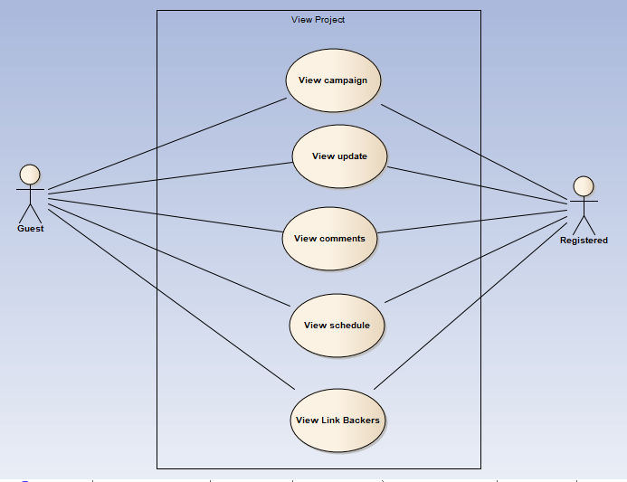

Figure 2-5: View Project Modal use case

##### UC004-View campaign

|  |  |  |  |  |
| --- | --- | --- | --- | --- |
| **Use Case ID** | | UC004 | **Version** | 1.1 |
| **Use Case Name** | | View campaign | | |
| **Created by:** | | MaiCTP | **Date Created:** | 24/09/2015 |
| **Primary Actor** | | Registered user  Guest | **Secondary Actor** |  |
| **Description:** | | This function allows user to view all common existing information of the project(description, risks, Q&A, …) | | |
| **Preconditions:** | | 1. DDL website is available  2. User browsed DDL website  3. User choose the project that user want to see | | |
| **Trigger:** | | User clicks on View Project button/ Name of the project. | | |
| **Post conditions:** | | Common information of this project is displayed | | |
| **Normal Flow** | | | | |
| **Step** | **Actor** | **Action** | | |
| 1 | User | Click on View Project button or Click on name of the project | | |
| 2 | DDL | Display View Project page includes  5 tabs:  -          Campaign  -          Update  -          Comments  -          Schedule  -          List Backers  With Campaign tab is default. | | |
| **Alternative Flows:  N/A** | | | | |
| **Exceptions: N/A** | | | | |
| **Priority** | | High | | |
| **Frequency of Use:** | | High | | |
| **Business Rules:** | | B1 | | |
| **Other Information:** | | N/A | | |

##### UC005-View update

|  |  |  |  |  |
| --- | --- | --- | --- | --- |
| **Use Case ID** | | UC005 | **Version** | 1.1 |
| **Use Case Name** | | View update | | |
| **Created by:** | | MaiCTP | **Date Created:** | 24/09/2015 |
| **Primary Actor** | | Registered user  Guest | **Secondary Actor** |  |
| **Description:** | | This function allows user to view all update existing information of the project | | |
| **Preconditions:** | | 1.       DDL website is available  2.       User browsed DDL website  3.       User choose the project that user want to see | | |
| **Trigger:** | | User clicks on Update tab | | |
| **Post conditions:** | | Update information of this project is displayed | | |
| **Normal Flow** | | | | |
| **Step** | **Actor** | **Action** | | |
| 1 | User | Click on View Project button or Click on name of the project | | |
| 2 | DDL | Display View Project page includes  5 tabs:  -          Campaign  -          Update  -          Comments  -          Schedule  -          List Backers  With Campaign tab is default. | | |
| 3 | User | Click on Update tab | | |
| 4 | DDL | Display Update page with all updated information. | | |
| **Alternative Flows:  N/A** | | | | |
| **Exceptions: N/A** | | | | |
| **Priority** | | High | | |
| **Frequency of Use:** | | High | | |
| **Business Rules:** | | B1 | | |
| **Other Information:** | | N/A | | |

##### UC006-View comments

|  |  |  |  |  |
| --- | --- | --- | --- | --- |
| **Use Case ID** | | UC006 | **Version** | 1.1 |
| **Use Case Name** | | View comments | | |
| **Created by:** | | MaiCTP | **Date Created:** | 24/09/2015 |
| **Primary Actor** | | Registered user  Guest | **Secondary Actor** |  |
| **Description:** | | This function allows user to view all existing comment of the project | | |
| **Preconditions:** | | 1.       DDL website is available  2.       User browsed DDL website  3.       User choose the project that user want to see | | |
| **Trigger:** | | User clicks on Comments tab | | |
| **Post conditions:** | | All comments of this project is displayed | | |
| **Normal Flow** | | | | |
| **Step** | **Actor** | **Action** | | |
| 1 | User | Click on View Project button or Click on name of the project | | |
| 2 | DDL | Display View Project page includes  5 tabs:  -          Campaign  -          Update  -          Comments  -          Schedule  -          List Backers  With Campaign tab is default. | | |
| 3 | User | Click on Comments tab | | |
| 4 | DDL | Display Comments page with all messages of this project. | | |
| **Alternative Flows:  N/A** | | | | |
| **Exceptions: N/A** | | | | |
| **Priority** | | High | | |
| **Frequency of Use:** | | High | | |
| **Business Rules:** | | B1 | | |
| **Other Information:** | | N/A | | |

##### UC007-View schedule

|  |  |  |  |  |
| --- | --- | --- | --- | --- |
| **Use Case ID** | | UC007 | **Version** | 1.1 |
| **Use Case Name** | | View schedule | | |
| **Created by:** | | MaiCTP | **Date Created:** | 24/09/2015 |
| **Primary Actor** | | Registered user  Guest | **Secondary Actor** |  |
| **Description:** | | This function allows user to view detailed schedule of the project | | |
| **Preconditions:** | | 1.       DDL website is available  2.       User browsed DDL website  3.       User choose the project that user want to see | | |
| **Trigger:** | | User clicks on Schedule tab | | |
| **Post conditions:** | | Detailed schedule of this project is displayed | | |
| **Normal Flow** | | | | |
| **Step** | **Actor** | **Action** | | |
| 1 | User | Click on View Project button or Click on name of the project | | |
| 2 | DDL | Display View Project page includes  5 tabs:  -          Campaign  -          Update  -          Comments  -          Schedule  -          List Backers  With Campaign tab is default. | | |
| 3 | User | -          Click on Schedule tab | | |
| 4 | DDL | -          Display Schedule page with all schedule of this project. | | |
| **Alternative Flows:** | | | | |
| **Exceptions: N/A** | | | | |
| **Priority** | | High | | |
| **Frequency of Use:** | | High | | |
| **Business Rules:** | | B1 | | |
| **Other Information:** | | N/A | | |

##### UC008-View Link Backers

|  |  |  |  |  |
| --- | --- | --- | --- | --- |
| **Use Case ID** | | UC008 | **Version** | 1.1 |
| **Use Case Name** | | View List Backers | | |
| **Created by:** | | MaiCTP | **Date Created:** | 24/09/2015 |
| **Primary Actor** | | Registered user  Guest | **Secondary Actor** |  |
| **Description:** | | This function allows user to view all Backers of the project | | |
| **Preconditions:** | | 1.       DDL website is available  2.       User browsed DDL website  3.       User choose the project that user want to see | | |
| **Trigger:** | | User clicks on List Backers tab | | |
| **Post conditions:** | | List backers of this project is displayed | | |
| **Normal Flow** | | | | |
| **Step** | **Actor** | **Action** | | |
| 1 | User | Click on View Project button or Click on name of the project | | |
| 2 | DDL | Display View Project page includes  5 tabs:  -          Campaign  -          Update  -          Comments  -          Schedule  -          List Backers  With Campaign tab is default. | | |
| 3 | User | -          Click on List Backers tab | | |
| 4 | DDL | -          Display List Backers page with all backers of this project. | | |
| **Alternative Flows:** | | | | |
| **Exceptions: N/A** | | | | |
| **Priority** | | High | | |
| **Frequency of Use:** | | High | | |
| **Business Rules:** | | B1 | | |
| **Other Information:** | | N/A | | |

#### Message

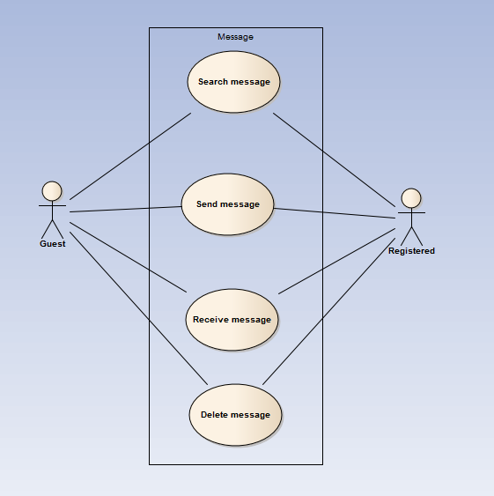

Figure 2-6: Message Modal use case

##### UC009-Search Message

|  |  |  |  |  |
| --- | --- | --- | --- | --- |
| **Use Case ID** | | UC009 | **Version** | 1.1 |
| **Use Case Name** | | Search message by content , sender | | |
| **Created by:** | | AnhDD | **Date Created:** | 24/09/2015 |
| **Primary Actor** | | Registered user | **Secondary Actor** |  |
| **Description:** | | DDL records all project which user backed | | |
| **Preconditions:** | | 1. DDL website is available  2.User browsed DDL website  3. User logged in to system | | |
| **Trigger:** | | User click Message then enters search phrase and click Search or press Enter | | |
| **Post conditions:** | | List all results that matched with the keyword user enters will be displayed in the Search Details screen | | |
| **Normal Flow** | | | | |
| **Step** | **Actor** | **Action** | | |
| 1 | User | Enter search phrase to text box | | |
| 2 | User | Click Search or press Enter | | |
| 3 | DDL | List all results that matched with the keyword user entered | | |
|  |  |  | | |
| **Alternative Flows: N/A** | | | | |
| **Exceptions:** | | | | |
| **EC1** | At step 3 in the main flows, if there is no result matched the keywords | | | |
| **Step** | **Actor** | **Action** | | |
| 3.1 | DDL | Display Basic Guide page with text: “Nothing found :(” | | |
|  | | | | |
| **Priority** | | Normal | | |
| **Frequency of Use:** | | Normal | | |
| **Business Rules:** | | N/A | | |
| **Other Information:** | | N/A | | |

##### UC010-Send Message

|  |  |  |  |  |
| --- | --- | --- | --- | --- |
| **Use Case ID** | | UC010 | **Version** | 1.1 |
| **Use Case Name** | | Send message | | |
| **Created by:** | | AnhDD | **Date Created:** | 24/09/2015 |
| **Primary Actor** | | Registered user | **Secondary Actor** |  |
| **Description:** | | This function allows user to send a message | | |
| **Preconditions:** | | 1. DDL website is available 2. User browsed DDL website 3. User logged in to system 4. User are on message page | | |
| **Trigger:** | | User enters message and click Send | | |
| **Post conditions:** | | Message page is displayed | | |
| **Normal Flow** | | | | |
| **Step** | **Actor** | **Action** | | |
|  | User | Filled all information ( subject , to , content ) | | |
|  | User | Click Send | | |
|  | DDL | Send this message | | |
|  | DDL | Displays message | | |
| **Alternative Flows:** | | | | |
| **AT1** | At step 2 in the main flows, if user click other hyperlinks or buttons | | | |
| **Step** | **Actor** | **Action** | | |
| 2.1 | DDL | Redirects user to chosen hyperlink or button | | |
|  | | | | |
| **AT2** | At step 2 in the main flows, if user click other hyperlinks or buttons | | | |
| **Step** | **Actor** | **Action** | | |
| 2.1 | DDL | Redirects user to chosen hyperlink or button | | |
|  | | | | |
| **Exceptions:** | | | | |
| **EC1** | Username of who user want to send a message is not exist | | | |
| **Step** | **Actor** | **Action** | | |
| 1 | DDL | Show a dialog error | | |
|  | | | | |
| **Priority** | | High | | |
| **Frequency of Use:** | | High | | |
| **Business Rules:** | |  | | |
| **Other Information:** | | N/A | | |

##### UC011-Delete Message

|  |  |  |  |  |
| --- | --- | --- | --- | --- |
| **Use Case ID** | | UC011 | **Version** | 1.1 |
| **Use Case Name** | | Delete message | | |
| **Created by:** | | AnhDD | **Date Created:** | 24/09/2015 |
| **Primary Actor** | | Registered user | **Secondary Actor** |  |
| **Description:** | | This function allows user to delete a message | | |
| **Preconditions:** | | 1.DDL website is available  2.User browsed DDL website  3.User logged in to system  4.User are on message page | | |
| **Trigger:** | | User choose a message then click delete | | |
| **Post conditions:** | | Message page is displayed | | |
| **Normal Flow** | | | | |
| **Step** | **Actor** | **Action** | | |
| 1 | User | Choose a message | | |
| 2 | User | Click Delete | | |
| 3 | DDL | Show confirm dialog | | |
| 4 | User | Confirm | | |
| 5 | DDL | Delete message | | |
| **Alternative Flows:** | | | | |
| **AT1** | At step 2 in the main flows, if user click other hyperlinks or buttons | | | |
| **Step** | **Actor** | **Action** | | |
| 2.1 | DDL | Redirects user to chosen hyperlink or button | | |
|  | | | | |
| **Exceptions: N/A** | | | | |
| **Priority** | | High | | |
| **Frequency of Use:** | | High | | |
| **Business Rules:** | |  | | |
| **Other Information:** | | N/A | | |

#### View Personal page

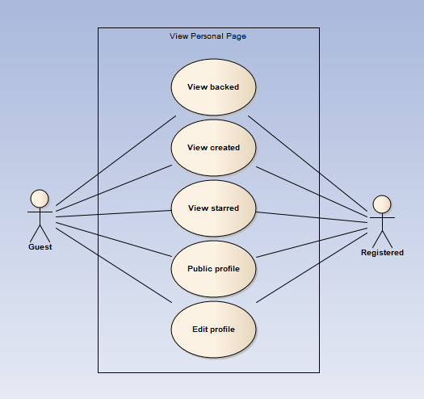

##### UC012- View backed

|  |  |  |  |  |
| --- | --- | --- | --- | --- |
| **Use Case ID** | | UC012 | **Version** | 1.1 |
| **Use Case Name** | | Display backed project | | |
| **Created by:** | | AnhDD | **Date Created:** | 24/09/2015 |
| **Primary Actor** | | Registered user | **Secondary Actor** |  |
| **Description:** | | DDL records all project which user backed | | |
| **Preconditions:** | | 1. DDL website is available  2.User browsed DDL website  3. User logged in to system | | |
| **Trigger:** | | User click View Backed Project | | |
| **Post conditions:** | | Backed Project Page is displayed | | |
| **Normal Flow** | | | | |
| **Step** | **Actor** | **Action** | | |
| 1 | User | Click Avatar image button in header | | |
| 2 | DDL | Display a menu includes:   * View Profile menu item * Logout menu item | | |
| 3 | User | Click View Profile | | |
| 4 | DDL | Redirect user to Profile page includes:   * Header * Backed project thumbnail | | |
| **Alternative Flows: N/A** | | | | |
| **Exceptions: N/A** | | | | |
| **Priority** | | High | | |
| **Frequency of Use:** | | High | | |
| **Business Rules:** | | N/A | | |
| **Other Information:** | | N/A | | |

##### UC013- View created project

|  |  |  |  |  |
| --- | --- | --- | --- | --- |
| **Use Case ID** | | UC013 | **Version** | 1.1 |
| **Use Case Name** | | Display created project | | |
| **Created by:** | | AnhDD | **Date Created:** | 24/09/2015 |
| **Primary Actor** | | Registered user | **Secondary Actor** |  |
| **Description:** | | DDL records all project which user backed | | |
| **Preconditions:** | | 1. DDL website is available  2.User browsed DDL website  3. User logged in to system | | |
| **Trigger:** | | User click View Created Project | | |
| **Post conditions:** | | Created Project Page is displayed | | |
| **Normal Flow** | | | | |
| **Step** | **Actor** | **Action** | | |
| 1 | User | Click Avatar image button in header | | |
| 2 | DDL | Display a menu includes:   * View Profile menu item * Logout menu item | | |
| 3 | User | Click View Profile | | |
| 4 | DDL | Redirect user to Profile page includes:   * Header * Created project thumbnail | | |
| **Alternative Flows: N/A** | | | | |
| **Exceptions: N/A** | | | | |
| **Priority** | | High | | |
| **Frequency of Use:** | | High | | |
| **Business Rules:** | | N/A | | |
| **Other Information:** | | N/A | | |

##### UC014- View starred project

|  |  |  |  |  |
| --- | --- | --- | --- | --- |
| **Use Case ID** | | UC014 | **Version** | 1.1 |
| **Use Case Name** | | Display starred project | | |
| **Created by:** | | AnhDD | **Date Created:** | 24/09/2015 |
| **Primary Actor** | | Registered user | **Secondary Actor** |  |
| **Description:** | | DDL records all project which user starred | | |
| **Preconditions:** | | 1. DDL website is available  2.User browsed DDL website  3. User logged in to system | | |
| **Trigger:** | | User click View Starred Project | | |
| **Post conditions:** | | Starred Project Page is displayed | | |
| **Normal Flow** | | | | |
| **Step** | **Actor** | **Action** | | |
| 1 | User | Click Avatar image button in header | | |
| 2 | DDL | Display a menu includes:   * View Profile menu item * Logout menu item | | |
| 3 | User | Click View Profile | | |
| 4 | DDL | Redirect user to Profile page includes:   * Header * Starred project thumbnail | | |
| **Alternative Flows: N/A** | | | | |
| **Exceptions: N/A** | | | | |
| **Priority** | | High | | |
| **Frequency of Use:** | | High | | |
| **Business Rules:** | | N/A | | |
| **Other Information:** | | N/A | | |

##### UC015- Public profile

|  |  |  |  |  |
| --- | --- | --- | --- | --- |
| **Use Case ID** | | UC015 | **Version** | 1.1 |
| **Use Case Name** | | Public profile | | |
| **Created by:** | | AnhDD | **Date Created:** | 24/09/2015 |
| **Primary Actor** | | Registered user | **Secondary Actor** |  |
| **Description:** | | DDL records all of user’s activities and display | | |
| **Preconditions:** | | 1. DDL website is available 2. User browsed DDL website 3. User logged in to system | | |
| **Trigger:** | | User click View Profile | | |
| **Post conditions:** | | Personal Page is displayed | | |
| **Normal Flow** | | | | |
| **Step** | **Actor** | **Action** | | |
| 1 | User | Click Avatar image button in header | | |
| 2 | DDL | Display a menu includes:   * View Profile menu item * Logout menu item | | |
| 3 | User | Click View Profile | | |
| 4 | DDL | Redirect user to Profile page includes:   * Header * Cover image label * Profile panel * Friend panel * Facebook connect status * Contact button | | |
| **Alternative Flows: N/A** | | | | |
| **Exceptions: N/A** | | | | |
| **Priority** | | High | | |
| **Frequency of Use:** | | High | | |
| **Business Rules:** | | N/A | | |
| **Other Information:** | | N/A | | |

##### UC016- Edit profile

|  |  |  |  |  |
| --- | --- | --- | --- | --- |
| **Use Case ID** | | UC016 | **Version** | 1.1 |
| **Use Case Name** | | Edit Profile | | |
| **Created by:** | | AnhDD | **Date Created:** | 24/09/2015 |
| **Primary Actor** | | Registered user | **Secondary Actor** |  |
| **Description:** | | This function allows user to edit profile | | |
| **Preconditions:** | | 1. DDL website is available  2.User browsed DDL website  3. User logged in to system | | |
| **Trigger:** | | User click Edit profile | | |
| **Post conditions:** | | Edit profile Page is displayed | | |
| **Normal Flow** | | | | |
| **Step** | **Actor** | **Action** | | |
| 1 | User | Click Avatar image button in header | | |
| 2 | DDL | Display a menu includes:   * View Profile menu item * Logout menu item | | |
| 3 | User | Click View Profile | | |
| 4 | DDL | Redirect user to Profile page includes:   * Header * Profile text box | | |
| **Alternative Flows: N/A** | | | | |
| **Exceptions: N/A** | | | | |
| **Priority** | | High | | |
| **Frequency of Use:** | | High | | |
| **Business Rules:** | | N/A | | |
| **Other Information:** | | N/A | | |

##### UC017- Change password

|  |  |  |  |  |
| --- | --- | --- | --- | --- |
| **Use Case ID** | | UC017 | **Version** | 1.1 |
| **Use Case Name** | | Change password | | |
| **Created by:** | | AnhDD | **Date Created:** | 24/09/2015 |
| **Primary Actor** | | Registered user | **Secondary Actor** |  |
| **Description:** | | This function allows user to change password | | |
| **Preconditions:** | | 1. DDL website is available  2.User browsed DDL website  3. User logged in to system | | |
| **Trigger:** | | User click Change password | | |
| **Post conditions:** | | Change password Page is displayed | | |
| **Normal Flow** | | | | |
| **Step** | **Actor** | **Action** | | |
| 1 | User | Click Avatar image button in header | | |
| 2 | DDL | Display a menu includes:   * View Profile menu item * Logout menu item | | |
| 3 | User | Click View Profile | | |
| 4 | DDL | Redirect user to Profile page includes:   * Header * Password and new password text box * Mail confirm text box | | |
| **Alternative Flows: N/A** | | | | |
| **Exceptions: N/A** | | | | |
| **Priority** | | High | | |
| **Frequency of Use:** | | High | | |
| **Business Rules:** | | N/A | | |
| **Other Information:** | | N/A | | |

### Guest Group Function

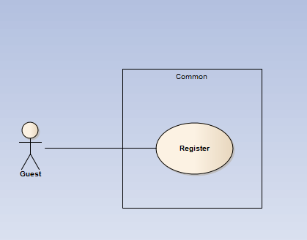

#### Common Module

##### UC018-Register

|  |  |  |  |  |
| --- | --- | --- | --- | --- |
| **Use Case ID** | | UC054 | **Version** | 1.1 |
| **Use Case Name** | | Unlock user’s account | | |
| **Created by:** | | LucPT | **Date Created:** | 28/05/2015 |
| **Primary Actor** | | Admin | **Secondary Actor** |  |
| **Description:** | | Administrator can unlock user account | | |
| **Preconditions:** | | 1. FAP must be connected to the Internet 2. User browsed FAP website 3. User logged into system as Admin 4. Only locked user can be unlock | | |
| **Trigger:** | | User click Unlock in User menu | | |
| **Post conditions:** | | 1. Chosen account is unlocked 2. Unlock notification is sent 3. User’s status is updated to database | | |
| **Normal Flow** | | | | |
| **Step** | **Actor** | **Action** | | |
|  | User | Click Locked list | | |
|  | User | Click a User name in Locked list | | |
|  | FAP | Displays a menu includes these hyperlinks:   * Add Friend * Unfriend * Edit Relationship * Follow * Block * Unlock * Warn | | |
|  | User | Click Unlock | | |
|  | FAP | Display confirm popup: “Unlock this user?” | | |
|  | User | Click OK | | |
|  | FAP | Unlocks chosen account | | |
|  | FAP | Sends notification to unlocked account: “Your account has been unlocked” | | |
| **Alternative Flows:** | | | | |
| **AT1** | At step 6 in the main flows, if user click Cancel | | | |
| **Step** | **Actor** | **Action** | | |
| 6.1 | FAP | Close popup | | |
| **Exceptions: N/A** | | | | |
| **Priority** | | High | | |
| **Frequency of Use:** | | High | | |
| **Business Rules:** | | N/A | | |
| **Other Information:** | | N/A | | |

### Registered Group Function

#### Common

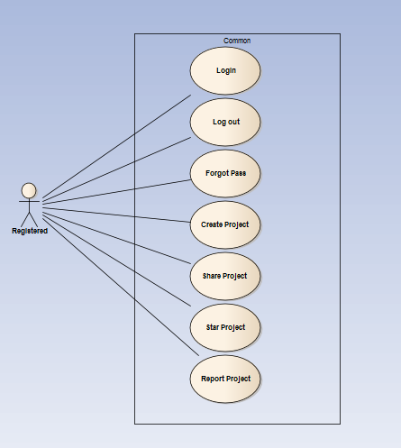

##### UC019- Login

|  |  |  |  |  |
| --- | --- | --- | --- | --- |
| **Use Case ID** | | UC019 | **Version** | 1.1 |
| **Use Case Name** | | Login by social network’s account  Login by registered account | | |
| **Created by:** | | AnhDD | **Date Created:** | 24/09/2015 |
| **Primary Actor** | | Registered User | **Secondary Actor** |  |
| **Description:** | | When Member want to login by Facebook/Google/Register account to use more functions in website | | |
| **Preconditions:** | | 1. DDL must be connected to the Internet 2. User browsed DDL website 3. Account Facebook/Google/Register must be exist and correctly 4. User are viewing Login page | | |
| **Trigger:** | | User enter flyawayplus.com | | |
| **Post conditions:** | | 1. Log user into system 2. Redirect user to previous page and display as Member | | |
| **Normal Flow** | | | | |
| **Step** | **Actor** | **Action** | | |
|  | User | Click Login in Homepage | | |
|  | DDL | Display Login popup includes:   * User name text box * Password text box * Login button * Cancel button * Facebook button * Google+ button * Forgot password hyperlink | | |
|  | User | Enters User name and Password | | |
|  | User | Click Login | | |
|  | DDL | Logs user into system | | |
|  | DDL | Close popup | | |
|  | DDL | Display previous page as Member | | |
| **Alternative Flows** | | | | |
| **AT1** | At step 3 in the main flows, if user click Facebook or Google+ button | | | |
| **Step** | **Actor** | **Action** | | |
| 3.1 | DDL | Redirects user to confirm site | | |
| 3.2 | DDL | Logs user into system with Facebook or Google+ account | | |
|  | | | | |
| **AT2** | At step 4, user choose Cancel: | | | |
| **Step** | **Actor** | **Action** | | |
| 4.1 | DDL | Closes popup. | | |
|  | | | | |
| **AT3** | At step 8 in the main flows, if user click other hyperlinks or buttons | | | |
| **Step** | **Actor** | **Action** | | |
| 8.1 | DDL | Redirects user to chosen hyperlink or button | | |
|  | | | | |
| **Exceptions:** | | | | |
| **EC1** | At step 4 in main flow, if user entered wrong User name or Password | | | |
| **Step** | **Actor** | **Action** | | |
| 3.1 | DDL | Display Login popup message with ID MSG14 | | |
| 3.2 | DDL | Mark error fields | | |
|  | | | | |
| **Priority** | | High | | |
| **Frequency of Use:** | | High | | |
| **Business Rules:** | | N/A | | |
| **Other Information:** | | N/A | | |

##### UC020- Logout

|  |  |  |  |  |
| --- | --- | --- | --- | --- |
| **Use Case ID** | | UC020 | **Version** | 1.1 |
| **Use Case Name** | | Logout | | |
| **Created by:** | | AnhDD | **Date Created:** | 24/09/2015 |
| **Primary Actor** | | User | **Secondary Actor** |  |
| **Description:** | | When Member want to logout their account | | |
| **Preconditions:** | | 1. DDL must be connected to the Internet 2. User browsed DDL website 3. User logged in to system | | |
| **Trigger:** | | User click Logout in header | | |
| **Post conditions:** | | 1. Log user out from system. 2. Redirect user to login page | | |
| **Normal Flow** | | | | |
| **Step** | **Actor** | **Action** | | |
| 1 | User | Click Logout | | |
| 2 | DDL | Display page as Guest | | |
| **Alternative Flows: N/A** | | | | |
| **Exceptions: N/A** | | | | |
| **Priority** | | High | | |
| **Frequency of Use:** | | High | | |
| **Business Rules:** | | N/A | | |
| **Other Information:** | | N/A | | |

##### UC021- Forgot password

|  |  |  |  |  |
| --- | --- | --- | --- | --- |
| **Use Case ID** | | UC021 | **Version** | 1.1 |
| **Use Case Name** | | Forgot password | | |
| **Created by:** | | AnhDD | **Date Created:** | 24/09/2015 |
| **Primary Actor** | | User/admin | **Secondary Actor** |  |
| **Description:** | | When Member, Admin forgot their password to login the system, this function will receiving their password to email | | |
| **Preconditions:** | | 1. DDL must be connected to the Internet 2. User browsed DDL website 3. User logged in to system | | |
| **Trigger:** | | Click Forgot password in Login popup | | |
| **Post conditions:** | | 1. Send confirm email | | |
| **Normal Flow** | | | | |
| **Step** | **Actor** | **Action** | | |
|  | User | Click Forgot password in Login popup | | |
|  | DDL | Display Email text box | | |
|  | User | Enter registered email | | |
|  | User | Click OK | | |
|  | DDL | Sends confirm email | | |
|  | DDL | Close popup | | |
| **Alternative Flows** | | | | |
| **AT2** | At step 3 in the main flow, user clicks on Cancel button | | | |
| **Step** | **Actor** | **Action** | | |
| 3.1 | DDL | Return to previous screen | | |
|  | | | | |
| **AT2** | At step 4 in the main flows, if user click other hyperlinks or buttons | | | |
| **Step** | **Actor** | **Action** | | |
| 4.1 | DDL | Redirects user to chosen hyperlink or button | | |
|  | | | | |
| **Exceptions:** | | | | |
| **EC1** | At step 4, entered email is invalid | | | |
| **Step** | **Actor** | **Action** | | |
| 4.1 | DDL | Displays Login popup with message: with ID MSG15 | | |
| 4.2 | DDL | Marks email text box | | |
|  | | | | |
| **Priority** | | High | | |
| **Frequency of Use:** | | High | | |
| **Business Rules:** | | N/A | | |
| **Other Information:** | | N/A | | |

##### UC022-Create Project

|  |  |  |  |  |
| --- | --- | --- | --- | --- |
| **Use Case ID** | | UC022 | **Version** | 1.1 |
| **Use Case Name** | | Create project | | |
| **Created by:** | | AnhDD | **Date Created:** | 24/09/2015 |
| **Primary Actor** | | Registered user | **Secondary Actor** |  |
| **Description:** | | This function allows user to create a project | | |
| **Preconditions:** | | 1.DDL website is available  2.User browsed DDL website  3.User logged in to system  4.User are on project information page | | |
| **Trigger:** | | User click on button start | | |
| **Post conditions:** | | Create a project page is displayed | | |
| **Normal Flow** | | | | |
| **Step** | **Actor** | **Action** | | |
| 1 | User | Click start | | |
| 2 | DDL | Show create project page basic | | |
| 3 | User | Choose rank , type and fill project name | | |
| 4 | User | Click button Start | | |
| 5 | DDL | Show create project page detail | | |
| 6 | User | Fill all information about project | | |
| 7 | User | Click Submit for review | | |
| 8 | DDL | Send message to admin for review | | |
| **Alternative Flows: N/A** | | | | |
| **Exceptions:** | | | | |
| **EC1** | At step 3 and 6 in the main flows, if user don’t fill all information of a project | | | |
| **Step** | **Actor** | **Action** | | |
| 3.1 | DDL | Display Dialog to remind user | | |
|  | | | | |
| **Priority** | | Normal | | |
| **Frequency of Use:** | | Normal | | |
| **Business Rules:** | | N/A | | |
| **Other Information:** | | N/A | | |

##### UC023- Share project

|  |  |  |  |  |
| --- | --- | --- | --- | --- |
| **Use Case ID** | | UC023 | **Version** | 1.1 |
| **Use Case Name** | | Share project | | |
| **Created by:** | | AnhDD | **Date Created:** | 24/09/2015 |
| **Primary Actor** | | Registered user | **Secondary Actor** |  |
| **Description:** | | This function allows user to share a project | | |
| **Preconditions:** | | 1.DDL website is available  2.User browsed DDL website  3.User logged in to system  4.User are on project information page | | |
| **Trigger:** | | User click on button report | | |
| **Post conditions:** | | Share a project page is displayed | | |
| **Normal Flow** | | | | |
| **Step** | **Actor** | **Action** | | |
| 1 | User | Choose a project | | |
| 2 | User | Click Share | | |
| 3 | DDL | Show dialog ask User confirm for share on Facebook | | |
| 4 | User | Click share to confirm | | |
| **Alternative Flows: N/A** | | | | |
| **Exceptions: N/A** | | | | |
| **Priority** | | High | | |
| **Frequency of Use:** | | High | | |
| **Business Rules:** | |  | | |
| **Other Information:** | | N/A | | |

##### UC024- Star project

|  |  |  |  |  |
| --- | --- | --- | --- | --- |
| **Use Case ID** | | UC024 | **Version** | 1.1 |
| **Use Case Name** | | Star project | | |
| **Created by:** | | AnhDD | **Date Created:** | 24/09/2015 |
| **Primary Actor** | | Registered user | **Secondary Actor** |  |
| **Description:** | | This function allows user to starr a project | | |
| **Preconditions:** | | 1.DDL website is available  2.User browsed DDL website  3.User logged in to system  4.User are on project information page | | |
| **Trigger:** | | User click on button report | | |
| **Post conditions:** | | Project page information is displayed | | |
| **Normal Flow** | | | | |
| **Step** | **Actor** | **Action** | | |
| 1 | User | Choose a project | | |
| 2 | User | Click on icon Star | | |
| 3 | DDL | Save this project into User’s Starred Project list | | |
| **Alternative Flows: N/A** | | | | |
| **Exceptions: N/A** | | | | |
| **Priority** | | High | | |
| **Frequency of Use:** | | High | | |
| **Business Rules:** | |  | | |
| **Other Information:** | | N/A | | |

##### UC025- Report project

|  |  |  |  |  |
| --- | --- | --- | --- | --- |
| **Use Case ID** | | UC025 | **Version** | 1.1 |
| **Use Case Name** | | Report project | | |
| **Created by:** | | AnhDD | **Date Created:** | 24/09/2015 |
| **Primary Actor** | | Registered user | **Secondary Actor** |  |
| **Description:** | | This function allows user to report a project | | |
| **Preconditions:** | | 1.DDL website is available  2.User browsed DDL website  3.User logged in to system  4.User are on project information page | | |
| **Trigger:** | | User click on button report | | |
| **Post conditions:** | | Project page information is displayed | | |
| **Normal Flow** | | | | |
| **Step** | **Actor** | **Action** | | |
| 1 | User | Choose a project | | |
| 2 | User | Click Report | | |
| 3 | DDL | Show confirm dialog with question ask about reason | | |
| 4 | User | Fill reason then confirm | | |
| 5 | DDL | Send report | | |
| **Alternative Flows: N/A** | | | | |
| **Exceptions: N/A** | | | | |
| **Priority** | | High | | |
| **Frequency of Use:** | | High | | |
| **Business Rules:** | |  | | |
| **Other Information:** | | N/A | | |

#### Comment

##### UC026- View list comment

|  |  |  |  |  |
| --- | --- | --- | --- | --- |
| **Use Case ID** | | UC026 | **Version** | 1.1 |
| **Use Case Name** | | View list comment | | |
| **Created by:** | | AnhDD | **Date Created:** | 24/09/2015 |
| **Primary Actor** | | Registered user | **Secondary Actor** |  |
| **Description:** | | DDL show all comment of a project | | |
| **Preconditions:** | | 1. DDL website is available  2. User browsed DDL website  3. User logged in to system  4. User clicked on a project | | |
| **Trigger:** | | User click on comment tab in project information page | | |
| **Post conditions:** | | Comment tab is displayed | | |
| **Normal Flow** | | | | |
| **Step** | **Actor** | **Action** | | |
| 1 | User | Click on a project | | |
| 2 | DDL | Display project information page | | |
| 3 | User | Click comment tab | | |
| 4 | DDL | Show comment tab include all comment of project | | |
| **Alternative Flows: N/A** | | | | |
| **Exceptions: N/A** | | | | |
| **Priority** | | High | | |
| **Frequency of Use:** | | High | | |
| **Business Rules:** | | N/A | | |
| **Other Information:** | | N/A | | |

##### UC027- Post comment

|  |  |  |  |  |
| --- | --- | --- | --- | --- |
| **Use Case ID** | | UC027 | **Version** | 1.1 |
| **Use Case Name** | | Post comment | | |
| **Created by:** | | AnhDD | **Date Created:** | 24/09/2015 |
| **Primary Actor** | | Registered user | **Secondary Actor** |  |
| **Description:** | | User post a comment | | |
| **Preconditions:** | | 1. DDL website is available  2. User browsed DDL website  3. User logged in to system  4. User clicked on a project | | |
| **Trigger:** | | User click on comment tab in project information page | | |
| **Post conditions:** | | Comment tab is displayed | | |
| **Normal Flow** | | | | |
| **Step** | **Actor** | **Action** | | |
| 1 | User | Click on a project | | |
| 2 | DDL | Display project information page | | |
| 3 | User | Click comment tab | | |
| 4 | DDL | Show comment tab include all comment of project | | |
| 5 | User | Fill the comment text box then click post | | |
| 6 | DDL | Post the comment user sent | | |
| **Alternative Flows: N/A** | | | | |
| **Exceptions: N/A** | | | | |
| **Priority** | | High | | |
| **Frequency of Use:** | | High | | |
| **Business Rules:** | | N/A | | |
| **Other Information:** | | N/A | | |

##### UC028- Edit comment

|  |  |  |  |  |
| --- | --- | --- | --- | --- |
| **Use Case ID** | | UC028 | **Version** | 1.1 |
| **Use Case Name** | | Edit comment | | |
| **Created by:** | | AnhDD | **Date Created:** | 24/09/2015 |
| **Primary Actor** | | Registered user | **Secondary Actor** |  |
| **Description:** | | User edit comment | | |
| **Preconditions:** | | 1. DDL website is available  2. User browsed DDL website  3. User logged in to system  4. User clicked on a project | | |
| **Trigger:** | | User click on comment tab in project information page | | |
| **Post conditions:** | | Comment tab is displayed | | |
| **Normal Flow** | | | | |
| **Step** | **Actor** | **Action** | | |
| 1 | User | Click on a project | | |
| 2 | DDL | Display project information page | | |
| 3 | User | Click comment tab | | |
| 4 | DDL | Show comment tab include all comment of project | | |
| 5 | User | Click edit on where user’s comment posted | | |
| 6 | DDL | Show edit comment text box | | |
| 7 | User | Edit then click post | | |
| **Alternative Flows: N/A** | | | | |
| **Exceptions: N/A** | | | | |
| **Priority** | | High | | |
| **Frequency of Use:** | | High | | |
| **Business Rules:** | | N/A | | |
| **Other Information:** | | N/A | | |

##### UC029- Delete comment

|  |  |  |  |  |
| --- | --- | --- | --- | --- |
| **Use Case ID** | | UC029 | **Version** | 1.1 |
| **Use Case Name** | | Delete comment | | |
| **Created by:** | | AnhDD | **Date Created:** | 24/09/2015 |
| **Primary Actor** | | Registered user | **Secondary Actor** |  |
| **Description:** | | User edit comment | | |
| **Preconditions:** | | 1. DDL website is available  2. User browsed DDL website  3. User logged in to system  4. User clicked on a project | | |
| **Trigger:** | | User click on comment tab in project information page | | |
| **Post conditions:** | | Comment tab is displayed | | |
| **Normal Flow** | | | | |
| **Step** | **Actor** | **Action** | | |
| 1 | User | Click on a project | | |
| 2 | DDL | Display project information page | | |
| 3 | User | Click comment tab | | |
| 4 | DDL | Show comment tab include all comment of project | | |
| 5 | User | Click delete on where user’s comment posted | | |
| 6 | DDL | Delete the comment | | |
|  |  |  | | |
| **Alternative Flows: N/A** | | | | |
| **Exceptions: N/A** | | | | |
| **Priority** | | High | | |
| **Frequency of Use:** | | High | | |
| **Business Rules:** | | N/A | | |
| **Other Information:** | | N/A | | |

#### Manage Project

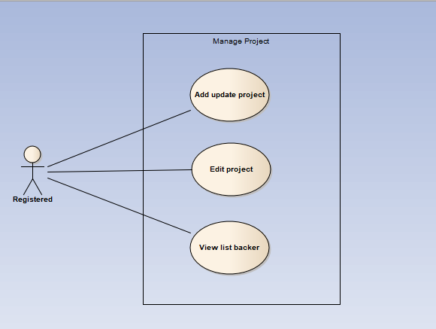

##### UC030- Edit Project

|  |  |  |  |  |
| --- | --- | --- | --- | --- |
| **Use Case ID** | | UC030 | **Version** | 1.1 |
| **Use Case Name** | | Edit Project | | |
| **Created by:** | | AnhDD | **Date Created:** | 24/09/2015 |
| **Primary Actor** | | Registered user | **Secondary Actor** |  |
| **Description:** | | This function allows user to edit Project | | |
| **Preconditions:** | | 1. DDL website is available  2.User browsed DDL website  3. User logged in to system | | |
| **Trigger:** | | User click Edit profile | | |
| **Post conditions:** | | Edit project Page is displayed | | |
| **Normal Flow** | | | | |
| **Step** | **Actor** | **Action** | | |
| 1 | User | Choose a project what user’s own | | |
| 2 | User | Click edit | | |
| 3 | User | Edit information | | |
| 4 | User | Click save | | |
| 5 | DDL | Save change | | |
| **Alternative Flows: N/A** | | | | |
| **Exceptions:** | | | | |
| **EC1** | At step 3 in the main flows, if user miss fill 1 or more information | | | |
| **Step** | **Actor** | **Action** | | |
| 3.1 | DDL | Display Dialog to remind user | | |
|  | | | | |
| **Priority** | | High | | |
| **Frequency of Use:** | | High | | |
| **Business Rules:** | | N/A | | |
| **Other Information:** | | N/A | | |

##### UC031-View list Backer

|  |  |  |  |  |
| --- | --- | --- | --- | --- |
| **Use Case ID** | | UC031 | **Version** | 1.1 |
| **Use Case Name** | | View list backer | | |
| **Created by:** | | AnhDD | **Date Created:** | 24/09/2015 |
| **Primary Actor** | | Registered user | **Secondary Actor** |  |
| **Description:** | | This function allows user to edit Project | | |
| **Preconditions:** | | 1. DDL website is available  2.User browsed DDL website  3. User logged in to system | | |
| **Trigger:** | | User click list backer tab | | |
| **Post conditions:** | | Project information page is displayed | | |
| **Normal Flow** | | | | |
| **Step** | **Actor** | **Action** | | |
| 1 | User | Choose a project what user’s own | | |
| 2 | User | Click on list backer tab | | |
| 3 | DDL | Show list backer table | | |
| **Alternative Flows: N/A** | | | | |
| **Exceptions: N/A** | | | | |
| **Priority** | | High | | |
| **Frequency of Use:** | | High | | |
| **Business Rules:** | | N/A | | |
| **Other Information:** | | N/A | | |

##### UC032-Add update project

|  |  |  |  |  |
| --- | --- | --- | --- | --- |
| **Use Case ID** | | UC032 | **Version** | 1.1 |
| **Use Case Name** | | Add update project | | |
| **Created by:** | | AnhDD | **Date Created:** | 24/09/2015 |
| **Primary Actor** | | Registered user | **Secondary Actor** |  |
| **Description:** | | This function allows user to edit Project | | |
| **Preconditions:** | | 1. DDL website is available  2.User browsed DDL website  3. User logged in to system | | |
| **Trigger:** | | User click add update | | |
| **Post conditions:** | | Project information page is displayed | | |
| **Normal Flow** | | | | |
| **Step** | **Actor** | **Action** | | |
| 1 | User | Choose a project what user’s own | | |
| 2 | User | Click on update tab | | |
| 3 | User | Click add update | | |
| 4 | User | Fill information about update | | |
| 5 | User | Click save | | |
| 6 | DDL | Add this update into update tab | | |
| **Alternative Flows: N/A** | | | | |
| **Exceptions: N/A** | | | | |
| **EC1** | At step 4 in the main flows, if user don’t fill information | | | |
| **Step** | **Actor** | **Action** | | |
| 3.1 | DDL | Display Dialog to remind user | | |
| **Priority** | | High | | |
| **Frequency of Use:** | | High | | |
| **Business Rules:** | | N/A | | |
| **Other Information:** | | N/A | | |

### Administrator Group Function

#### Common

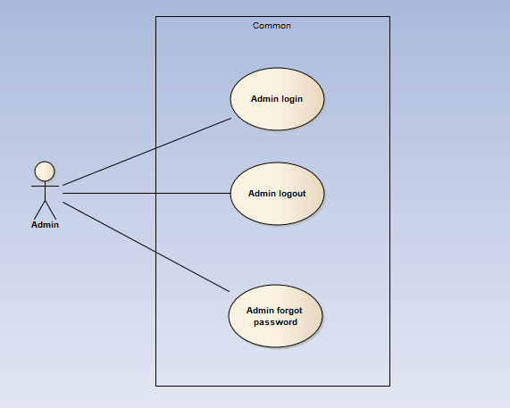

##### UC033- Admin login

|  |  |  |  |  |
| --- | --- | --- | --- | --- |
| **Use Case ID** | | UC033 | **Version** | 1.1 |
| **Use Case Name** | | Admin login | | |
| **Created by:** | | MaiCTP | **Date Created:** | 28/09/2015 |
| **Primary Actor** | | Administrator(Admin) | **Secondary Actor** |  |
| **Description:** | | This function allows Admin logins into website | | |
| **Preconditions:** | | 1. DDL website is available 2. Admin browsed DDL website 3. Admin are viewing Login page for admin | | |
| **Trigger:** | | Admin clicks on Login button | | |
| **Post conditions:** | | 1. Log Admin into system 2. Redirect Admin to Admin home page | | |
| **Normal Flow** | | | | |
| **Step** | **Actor** | **Action** | | |
| 1 | DDL | Display Admin Login page. If Admin choose Remember Me function before, fill all needed information | | |
| 2 | Admin | Type email address and password if Admin does not choose Remember Me function before | | |
| 3 | DDL | Verify:   * 1. Email address   2. Password | | |
| 4 | DDL | * Log Admin into system * Redirect Admin to Admin home page | | |
| **Alternative Flows: N/A** | | | | |
| **Exceptions:** | | | | |

|  |  |  |
| --- | --- | --- |
| **EC1** | At step 2 in main flow, if Admin entered wrong Email address or Password | |
| **Step** | **Actor** | **Action** |
| 2.1 | DDL | Display Login popup message point out error field |
| 2.2 | DDL | Mark error fields |

|  |  |
| --- | --- |
| **Priority** | High |
| **Frequency of Use:** | High |
| **Business Rules:** | B1 |
| **Other Information:** | N/A |

##### UC034- Admin logout

|  |  |  |  |  |
| --- | --- | --- | --- | --- |
| **Use Case ID** | | UC034 | **Version** | 1.1 |
| **Use Case Name** | | Admin logout | | |
| **Created by:** | | MaiCTP | **Date Created:** | 28/09/2015 |
| **Primary Actor** | | Administrator(Admin) | **Secondary Actor** |  |
| **Description:** | | This function allows Admin logouts of DDL website | | |
| **Preconditions:** | | 1. Admin logged in DDL website as Administrator | | |
| **Trigger:** | | Admin clicks on Logout option | | |
| **Post conditions:** | | Admin is logged out from DDL website | | |
| **Normal Flow** | | | | |
| **Step** | **Actor** | **Action** | | |
| 1 | Admin | * Click on dropdown at right side of DDL website * Choose Logout option | | |
| 2 | DDL | * Logout Admin * Redirect to Admin Login page | | |
| **Alternative Flows:N/A** | | | | |
| **Exceptions: N/A** | | | | |
| **Priority** | | High | | |
| **Frequency of Use:** | | High | | |
| **Business Rules:** | | B1 | | |
| **Other Information:** | | N/A | | |

##### UC035- Admin forgot password

|  |  |  |  |  |
| --- | --- | --- | --- | --- |
| **Use Case ID** | | UC035 | **Version** | 1.1 |
| **Use Case Name** | | Admin forgot password | | |
| **Created by:** | | MaiCTP | **Date Created:** | 28/09/2015 |
| **Primary Actor** | | Administrator(Admin) | **Secondary Actor** |  |
| **Description:** | | This function allows Admin receiving her/ his password to email | | |
| **Preconditions:** | | 1. DDL website is available 2. Admin browsed DDL website 3. Admin are viewing Login page for admin | | |
| **Trigger:** | | Click Forgot password in Login page | | |
| **Post conditions:** | | Admin get new password on her/ his email | | |
| **Normal Flow** | | | | |
| **Step** | **Actor** | **Action** | | |

|  |  |  |
| --- | --- | --- |
|  | Admin | Click Forgot password in Login popup |
|  | DDL | Display Email text box |
|  | Admin | Enter registered email |
|  | Admin | Click OK |
|  | DDL | Sends confirm email |
|  | DDL | Close popup |

|  |
| --- |
| **Alternative Flows:** |

|  |  |  |
| --- | --- | --- |
| **AT1** | At step 3 in the main flow, Admin clicks on Cancel button | |
| **Step** | **Actor** | **Action** |
| 3.1 | DDL | Return to previous screen |
|  | | |
| **AT2** | At step 4 in the main flows, if Admin click other hyperlinks or buttons | |
| **Step** | **Actor** | **Action** |
| 4.1 | DDL | Redirects Admin to chosen hyperlink or button |
|  | | |
| **Exceptions:** | | |
| **EC1** | At step 4, entered email is invalid | |
| **Step** | **Actor** | **Action** |
| 4.1 | DDL | Displays Login popup with error message |
| 4.2 | DDL | Marks email text box |
|  | | |

|  |  |
| --- | --- |
| **Priority** | High |
| **Frequency of Use:** | High |
| **Business Rules:** | B1 |
| **Other Information:** | N/A |

#### Manage user's account

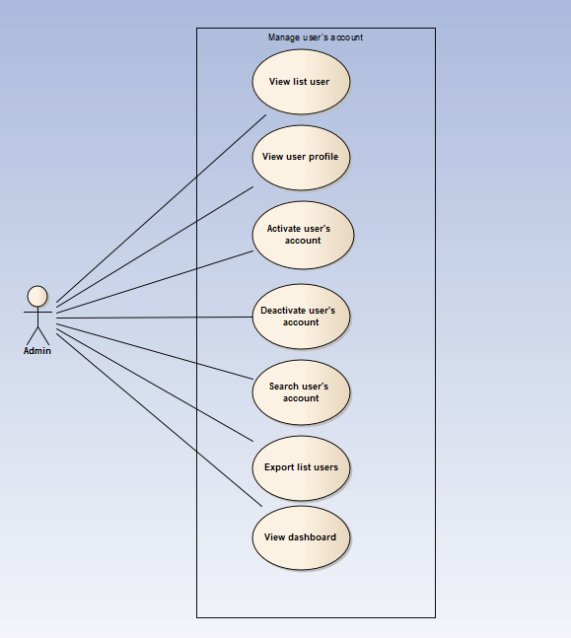

##### UC036- View user list

|  |  |  |  |  |
| --- | --- | --- | --- | --- |
| **Use Case ID** | | UC036 | **Version** | 1.1 |
| **Use Case Name** | | View user list | | |
| **Created by:** | | MaiCTP | **Date Created:** | 28/09/2015 |
| **Primary Actor** | | Administrator(Admin) | **Secondary Actor** |  |
| **Description:** | | This function allows Administrator to view User list of the project | | |
| **Preconditions:** | | 1. DDL website is available 2. Admin browsed DDL website 3. Admin logged in as Administrator | | |
| **Trigger:** | | Admin clicks on Users List | | |
| **Post conditions:** | | Users List is displayed | | |
| **Normal Flow** | | | | |
| **Step** | **Actor** | **Action** | | |
| 1 | Admin | * Click on Users at left side * Click on Users List | | |
| 2 | DDL | Display list of users | | |
| **Alternative Flows:** | | | | |

|  |  |  |
| --- | --- | --- |
| **AT1** | At step 1 in the main flows, if do not have any user | |
| **Step** | **Actor** | **Action** |
| 2.1 | DDL | Display “Do not have any user” message |
|  | | |

|  |  |
| --- | --- |
| **Exceptions: N/A** | |
| **Priority** | High |
| **Frequency of Use:** | High |
| **Business Rules:** | B1 |
| **Other Information:** | N/A |

##### UC037- View user profile

|  |  |  |  |  |
| --- | --- | --- | --- | --- |
| **Use Case ID** | | UC037 | **Version** | 1.1 |
| **Use Case Name** | | View user profile | | |
| **Created by:** | | MaiCTP | **Date Created:** | 28/09/2015 |
| **Primary Actor** | | Administrator(Admin) | **Secondary Actor** |  |
| **Description:** | | This function allows Administrator to view profile of an user | | |
| **Preconditions:** | | Admin is viewing Users List | | |
| **Trigger:** | | Admin clicks on View button | | |
| **Post conditions:** | | Profile of this user is displayed | | |
| **Normal Flow** | | | | |
| **Step** | **Actor** | **Action** | | |
| 1 | Admin | Click on View button at Action column of the user whom want to see profile | | |
| 2 | DDL | Display profile of this user | | |
| **Alternative Flows: N/A** | | | | |
| **Exceptions: N/A** | | | | |
| **Priority** | | High | | |
| **Frequency of Use:** | | High | | |
| **Business Rules:** | | B1 | | |
| **Other Information:** | | N/A | | |

##### UC038- Activate user's account

|  |  |  |  |  |
| --- | --- | --- | --- | --- |
| **Use Case ID** | | UC038 | **Version** | 1.1 |
| **Use Case Name** | | Activate user's account | | |
| **Created by:** | | MaiCTP | **Date Created:** | 28/09/2015 |
| **Primary Actor** | | Administrator(Admin) | **Secondary Actor** |  |
| **Description:** | | This function allows Administrator to activate an user’s account | | |
| **Preconditions:** | | * Admin is viewing Users List * Status of this user is deactivate | | |
| **Trigger:** | | Admin clicks on Deactivate button | | |
| **Post conditions:** | | User’s account is activated | | |
| **Normal Flow** | | | | |
| **Step** | **Actor** | **Action** | | |
| 1 | Admin | Click on Deactivate button at Status column of the user whom want to activate | | |
| 2 | DDL | * Change displayed status from Deactivate to Activate * Change status of this user’s account to Activate on database | | |
| **Alternative Flows: N/A** | | | | |
| **Exceptions: N/A** | | | | |
| **Priority** | | High | | |
| **Frequency of Use:** | | High | | |
| **Business Rules:** | | B1 | | |
| **Other Information:** | | N/A | | |

##### UC039- Deactivate user's account

|  |  |  |  |  |
| --- | --- | --- | --- | --- |
| **Use Case ID** | | UC039 | **Version** | 1.1 |
| **Use Case Name** | | Deactivate user's account | | |
| **Created by:** | | MaiCTP | **Date Created:** | 28/09/2015 |
| **Primary Actor** | | Administrator(Admin) | **Secondary Actor** |  |
| **Description:** | | This function allows Administrator to deactivate an user’s account | | |
| **Preconditions:** | | * Admin is viewing Users List * Status of this user is activate | | |
| **Trigger:** | | Admin clicks on Activate button | | |
| **Post conditions:** | | User’s account is deactivated | | |
| **Normal Flow** | | | | |
| **Step** | **Actor** | **Action** | | |
| 1 | Admin | Click on Activate button at Status column of the user whom want to deactivate | | |
| 2 | DDL | * Change displayed status from Activate to Deactivate * Change status of this user’s account to Deactivate on database | | |
| **Alternative Flows: N/A** | | | | |
| **Exceptions: N/A** | | | | |
| **Priority** | | High | | |
| **Frequency of Use:** | | High | | |
| **Business Rules:** | | B1 | | |
| **Other Information:** | | N/A | | |

##### UC040- Search user's account

|  |  |  |  |  |
| --- | --- | --- | --- | --- |
| **Use Case ID** | | UC040 | **Version** | 1.1 |
| **Use Case Name** | | Search user's account | | |
| **Created by:** | | MaiCTP | **Date Created:** | 28/09/2015 |
| **Primary Actor** | | Administrator(Admin) | **Secondary Actor** |  |
| **Description:** | | This function allows Administrator to search an user’s account | | |
| **Preconditions:** | | Admin is viewing Users List | | |
| **Trigger:** | | Admin types name of user at Search textbox | | |
| **Post conditions:** | | Display list of searched user | | |
| **Normal Flow** | | | | |
| **Step** | **Actor** | **Action** | | |
| 1 | Admin | * Type name of user whom want to search | | |
| 2 | DDL | * Display list of users who have the name is typed | | |
| **Alternative Flows:** | | | | |

|  |  |  |
| --- | --- | --- |
| **AT1** | At step 1 in the main flows, if the typed name is not exist | |
| **Step** | **Actor** | **Action** |
| 2.1 | DDL | Display “No matching records found” message |
|  | | |

|  |  |
| --- | --- |
| **Exceptions: N/A** | |
| **Priority** | High |
| **Frequency of Use:** | High |
| **Business Rules:** | B1 |
| **Other Information:** | N/A |

##### UC041- Export user list

|  |  |  |  |  |
| --- | --- | --- | --- | --- |
| **Use Case ID** | | UC041 | **Version** | 1.1 |
| **Use Case Name** | | Export user list | | |
| **Created by:** | | MaiCTP | **Date Created:** | 28/09/2015 |
| **Primary Actor** | | Administrator(Admin) | **Secondary Actor** |  |
| **Description:** | | This function allows Administrator to export list of users | | |
| **Preconditions:** | | * Admin is viewing Users List | | |
| **Trigger:** | | Admin clicks on Export button | | |
| **Post conditions:** | | List of users is exported | | |
| **Normal Flow** | | | | |
| **Step** | **Actor** | **Action** | | |
| 1 | Admin | Click on Export button at right side User list table | | |
| 2 | DDL | Export list of users to file | | |
| **Alternative Flows: N/A** | | | | |
| **Exceptions: N/A** | | | | |
| **Priority** | | High | | |
| **Frequency of Use:** | | High | | |
| **Business Rules:** | | B1 | | |
| **Other Information:** | | N/A | | |

##### UC042- View user’s dashboard

|  |  |  |  |  |
| --- | --- | --- | --- | --- |
| **Use Case ID** | | UC042 | **Version** | 1.1 |
| **Use Case Name** | | View user’s dashboard | | |
| **Created by:** | | MaiCTP | **Date Created:** | 28/09/2015 |
| **Primary Actor** | | Administrator(Admin) | **Secondary Actor** |  |
| **Description:** | | This function allows Administrator to view dashboard about user of the project | | |
| **Preconditions:** | | 1. DDL website is available 2. Admin browsed DDL website 3. Admin logged in as Administrator | | |
| **Trigger:** | | Admin clicks on Dashboard | | |
| **Post conditions:** | | Dashboard about user is displayed | | |
| **Normal Flow** | | | | |
| **Step** | **Actor** | **Action** | | |
| 1 | Admin | * Click on Users at left side * Click on Dashboard | | |
| 2 | DDL | Display User Dashboard page | | |
| **Alternative Flows: N/A** | | | | |
| **Exceptions: N/A** | | | | |
| **Priority** | | High | | |
| **Frequency of Use:** | | High | | |
| **Business Rules:** | | B1 | | |
| **Other Information:** | | N/A | | |

#### Manage projects

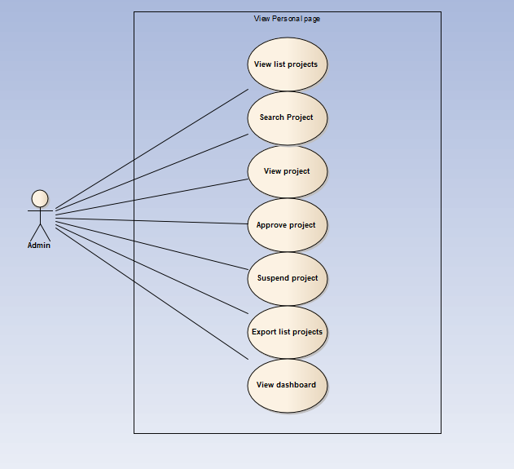

##### UC043- View project list

|  |  |  |  |  |
| --- | --- | --- | --- | --- |
| **Use Case ID** | | UC043 | **Version** | 1.1 |
| **Use Case Name** | | View project list | | |
| **Created by:** | | MaiCTP | **Date Created:** | 28/09/2015 |
| **Primary Actor** | | Administrator(Admin) | **Secondary Actor** |  |
| **Description:** | | This function allows Administrator to view project list of the project | | |
| **Preconditions:** | | 1. DDL website is available 2. Admin browsed DDL website 3. Admin logged in as Administrator | | |
| **Trigger:** | | Admin clicks on Projects List | | |
| **Post conditions:** | | Project List is displayed | | |
| **Normal Flow** | | | | |
| **Step** | **Actor** | **Action** | | |
| 1 | Admin | * Click on Project at left side * Click on Projects List | | |
| 2 | DDL | Display list of projects | | |
| **Alternative Flows:** | | | | |

|  |  |  |
| --- | --- | --- |
| **AT1** | At step 1 in the main flows, if do not have any project | |
| **Step** | **Actor** | **Action** |
| 2.1 | DDL | Display “Do not have any project” message |
|  | | |

|  |  |
| --- | --- |
| **Exceptions: N/A** | |
| **Priority** | High |
| **Frequency of Use:** | High |
| **Business Rules:** | B1 |
| **Other Information:** | N/A |

##### UC044- Search project

|  |  |  |  |  |
| --- | --- | --- | --- | --- |
| **Use Case ID** | | UC044 | **Version** | 1.1 |
| **Use Case Name** | | Search project | | |
| **Created by:** | | MaiCTP | **Date Created:** | 28/09/2015 |
| **Primary Actor** | | Administrator(Admin) | **Secondary Actor** |  |
| **Description:** | | This function allows Administrator to search a project | | |
| **Preconditions:** | | Admin is viewing Projects List | | |
| **Trigger:** | | Admin types name of project on Search textbox | | |
| **Post conditions:** | | Display list of searched project | | |
| **Normal Flow** | | | | |
| **Step** | **Actor** | **Action** | | |
| 1 | Admin | * Type name of project which want to search | | |
| 2 | DDL | * Display list of projects which have the name is typed | | |
| **Alternative Flows:** | | | | |

|  |  |  |
| --- | --- | --- |
| **AT1** | At step 1 in the main flows, if the typed name is not exist | |
| **Step** | **Actor** | **Action** |
| 2.1 | DDL | Display “No matching records found” message |
|  | | |

|  |  |
| --- | --- |
| **Exceptions: N/A** | |
| **Priority** | High |
| **Frequency of Use:** | High |
| **Business Rules:** | B1 |
| **Other Information:** | N/A |

##### UC045- View (review) project

|  |  |  |  |  |
| --- | --- | --- | --- | --- |
| **Use Case ID** | | UC045 | **Version** | 1.1 |
| **Use Case Name** | | View (review) project | | |
| **Created by:** | | MaiCTP | **Date Created:** | 28/09/2015 |
| **Primary Actor** | | Administrator(Admin) | **Secondary Actor** |  |
| **Description:** | | This function allows Administrator to view information of a project | | |
| **Preconditions:** | | Admin is viewing Project List | | |
| **Trigger:** | | Admin clicks on button at Action column | | |
| **Post conditions:** | | Information of this project is displayed | | |
| **Normal Flow** | | | | |
| **Step** | **Actor** | **Action** | | |
| 1 | Admin | Admin clicks on button at Action column of the project which want to view information | | |
| 2 | DDL | Display Project Detail page of this project | | |
| **Alternative Flows: N/A** | | | | |
| **Exceptions: N/A** | | | | |
| **Priority** | | High | | |
| **Frequency of Use:** | | High | | |
| **Business Rules:** | | B1 | | |
| **Other Information:** | | N/A | | |

##### UC046- Approve project

|  |  |  |  |  |
| --- | --- | --- | --- | --- |
| **Use Case ID** | | UC046 | **Version** | 1.1 |
| **Use Case Name** | | Approve project | | |
| **Created by:** | | MaiCTP | **Date Created:** | 28/09/2015 |
| **Primary Actor** | | Administrator(Admin) | **Secondary Actor** |  |
| **Description:** | | This function allows Administrator to approve a project | | |
| **Preconditions:** | | * Admin is viewing Project List * Status of this Project is Suspend | | |
| **Trigger:** | | Admin clicks on button at Status column | | |
| **Post conditions:** | | This project is approved | | |
| **Normal Flow** | | | | |
| **Step** | **Actor** | **Action** | | |
| 1 | Admin | Click on button at Status column of the project which want to approve | | |
| 2 | DDL | * Change displayed status to Approve * Change status of this user’s account to Approve on database | | |
| **Alternative Flows: N/A** | | | | |
| **Exceptions: N/A** | | | | |
| **Priority** | | High | | |
| **Frequency of Use:** | | High | | |
| **Business Rules:** | | B1 | | |
| **Other Information:** | | N/A | | |

##### UC047- Suspend project

|  |  |  |  |  |
| --- | --- | --- | --- | --- |
| **Use Case ID** | | UC047 | **Version** | 1.1 |
| **Use Case Name** | | Suspend project | | |
| **Created by:** | | MaiCTP | **Date Created:** | 28/09/2015 |
| **Primary Actor** | | Administrator(Admin) | **Secondary Actor** |  |
| **Description:** | | This function allows Administrator to suspend a project | | |
| **Preconditions:** | | * Admin is viewing Project List * Status of this Project is Approve | | |
| **Trigger:** | | Admin clicks on button at Status column | | |
| **Post conditions:** | | This project is suspended | | |
| **Normal Flow** | | | | |
| **Step** | **Actor** | **Action** | | |
| 1 | Admin | Click on button at Status column of the project which want to suspend | | |
| 2 | DDL | * Change displayed status to Suspend * Change status of this user’s account to Suspend on database | | |
| **Alternative Flows: N/A** | | | | |
| **Exceptions: N/A** | | | | |
| **Priority** | | High | | |
| **Frequency of Use:** | | High | | |
| **Business Rules:** | | B1 | | |
| **Other Information:** | | N/A | | |

##### UC048- Export project list

|  |  |  |  |  |
| --- | --- | --- | --- | --- |
| **Use Case ID** | | UC048 | **Version** | 1.1 |
| **Use Case Name** | | Export users list | | |
| **Created by:** | | MaiCTP | **Date Created:** | 28/09/2015 |
| **Primary Actor** | | Administrator(Admin) | **Secondary Actor** |  |
| **Description:** | | This function allows Administrator to export list of projects | | |
| **Preconditions:** | | * Admin is viewing Project List | | |
| **Trigger:** | | Admin clicks on Export button | | |
| **Post conditions:** | | List of projects is exported | | |
| **Normal Flow** | | | | |
| **Step** | **Actor** | **Action** | | |
| 1 | Admin | Click on Export button at right side Project list table | | |
| 2 | DDL | Export list of projects to file | | |
| **Alternative Flows: N/A** | | | | |
| **Exceptions: N/A** | | | | |
| **Priority** | | High | | |
| **Frequency of Use:** | | High | | |
| **Business Rules:** | | B1 | | |
| **Other Information:** | | N/A | | |

##### UC049- View project’s dashboard

|  |  |  |  |  |
| --- | --- | --- | --- | --- |
| **Use Case ID** | | UC049 | **Version** | 1.1 |
| **Use Case Name** | | View project’s dashboard | | |
| **Created by:** | | MaiCTP | **Date Created:** | 28/09/2015 |
| **Primary Actor** | | Administrator(Admin) | **Secondary Actor** |  |
| **Description:** | | This function allows Administrator to view dashboard about project of the project | | |
| **Preconditions:** | | 1. DDL website is available 2. Admin browsed DDL website 3. Admin logged in as Administrator | | |
| **Trigger:** | | Admin clicks on Dashboard | | |
| **Post conditions:** | | Dashboard about project is displayed | | |
| **Normal Flow** | | | | |
| **Step** | **Actor** | **Action** | | |
| 1 | Admin | * Click on Project at left side * Click on Dashboard | | |
| 2 | DDL | Display Project Dashboard page | | |
| **Alternative Flows: N/A** | | | | |
| **Exceptions: N/A** | | | | |
| **Priority** | | High | | |
| **Frequency of Use:** | | High | | |
| **Business Rules:** | | B1 | | |
| **Other Information:** | | N/A | | |

#### Manage backings

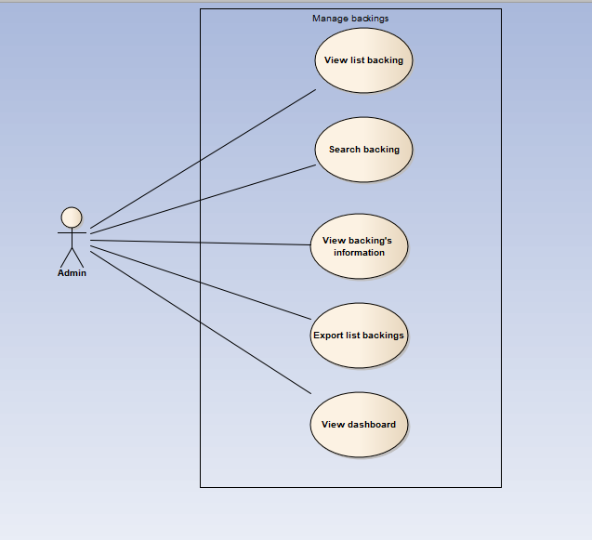

##### UC050- View backing list

|  |  |  |  |  |
| --- | --- | --- | --- | --- |
| **Use Case ID** | | UC050 | **Version** | 1.1 |
| **Use Case Name** | | View backing list | | |
| **Created by:** | | MaiCTP | **Date Created:** | 28/09/2015 |
| **Primary Actor** | | Administrator(Admin) | **Secondary Actor** |  |
| **Description:** | | This function allows Administrator to view Backing list of the project | | |
| **Preconditions:** | | 1. DDL website is available 2. Admin browsed DDL website 3. Admin logged in as Administrator | | |
| **Trigger:** | | Admin clicks on Backing | | |
| **Post conditions:** | | Backing List is displayed | | |
| **Normal Flow** | | | | |
| **Step** | **Actor** | **Action** | | |
| 1 | Admin | Click on Backing at left side | | |
| 2 | DDL | Display list of backings | | |
| **Alternative Flows:** | | | | |

|  |  |  |
| --- | --- | --- |
| **AT1** | At step 1 in the main flows, if do not have any backing | |
| **Step** | **Actor** | **Action** |
| 2.1 | DDL | Display “Do not have any backing” message |
|  | | |

|  |  |
| --- | --- |
| **Exceptions: N/A** | |
| **Priority** | High |
| **Frequency of Use:** | High |
| **Business Rules:** | B1 |
| **Other Information:** | N/A |

##### UC051- Search project

|  |  |  |  |  |
| --- | --- | --- | --- | --- |
| **Use Case ID** | | UC051 | **Version** | 1.1 |
| **Use Case Name** | | Search backing | | |
| **Created by:** | | MaiCTP | **Date Created:** | 28/09/2015 |
| **Primary Actor** | | Administrator(Admin) | **Secondary Actor** |  |
| **Description:** | | This function allows Administrator to search a backing | | |
| **Preconditions:** | | Admin is viewing Backing List | | |
| **Trigger:** | | Admin types name of backing on Search textbox | | |
| **Post conditions:** | | Display list of searched backing | | |
| **Normal Flow** | | | | |
| **Step** | **Actor** | **Action** | | |
| 1 | Admin | * Type name of backing which want to search | | |
| 2 | DDL | * Display list of backings which have the name is typed | | |
| **Alternative Flows:** | | | | |

|  |  |  |
| --- | --- | --- |
| **AT1** | At step 1 in the main flows, if the typed name is not exist | |
| **Step** | **Actor** | **Action** |
| 2.1 | DDL | Display “No matching records found” message |
|  | | |

|  |  |
| --- | --- |
| **Exceptions: N/A** | |
| **Priority** | High |
| **Frequency of Use:** | High |
| **Business Rules:** | B1 |
| **Other Information:** | N/A |

##### UC052- View backing's information

|  |  |  |  |  |
| --- | --- | --- | --- | --- |
| **Use Case ID** | | UC052 | **Version** | 1.1 |
| **Use Case Name** | | View backing's information | | |
| **Created by:** | | MaiCTP | **Date Created:** | 28/09/2015 |
| **Primary Actor** | | Administrator(Admin) | **Secondary Actor** |  |
| **Description:** | | This function allows Administrator to view information of a backing | | |
| **Preconditions:** | | Admin is viewing Backing List | | |
| **Trigger:** | | Admin clicks on button at Action column | | |
| **Post conditions:** | | Information of this backing is displayed | | |
| **Normal Flow** | | | | |
| **Step** | **Actor** | **Action** | | |
| 1 | Admin | Admin clicks on button at Action column of the backing which want to view information | | |
| 2 | DDL | Display Backing’s information popup | | |
| **Alternative Flows: N/A** | | | | |
| **Exceptions: N/A** | | | | |
| **Priority** | | High | | |
| **Frequency of Use:** | | High | | |
| **Business Rules:** | | B1 | | |
| **Other Information:** | | N/A | | |

##### UC053- Export backings list

|  |  |  |  |  |
| --- | --- | --- | --- | --- |
| **Use Case ID** | | UC053 | **Version** | 1.1 |
| **Use Case Name** | | Export backings list | | |
| **Created by:** | | MaiCTP | **Date Created:** | 28/09/2015 |
| **Primary Actor** | | Administrator(Admin) | **Secondary Actor** |  |
| **Description:** | | This function allows Administrator to export list of backings | | |
| **Preconditions:** | | Admin is viewing Backings List | | |
| **Trigger:** | | Admin clicks on Export button | | |
| **Post conditions:** | | List of backings is exported | | |
| **Normal Flow** | | | | |
| **Step** | **Actor** | **Action** | | |
| 1 | Admin | Click on Export button at right side Backings list table | | |
| 2 | DDL | Export list of backings to file | | |
| **Alternative Flows: N/A** | | | | |
| **Exceptions: N/A** | | | | |
| **Priority** | | High | | |
| **Frequency of Use:** | | High | | |
| **Business Rules:** | | B1 | | |
| **Other Information:** | | N/A | | |

##### UC054- View backing’s dashboard

|  |  |  |  |  |
| --- | --- | --- | --- | --- |
| **Use Case ID** | | UC054 | **Version** | 1.1 |
| **Use Case Name** | | View backing’s dashboard | | |
| **Created by:** | | MaiCTP | **Date Created:** | 28/09/2015 |
| **Primary Actor** | | Administrator(Admin) | **Secondary Actor** |  |
| **Description:** | | This function allows Administrator to view dashboard about backing of the project | | |
| **Preconditions:** | | 1. DDL website is available 2. Admin browsed DDL website 3. Admin logged in as Administrator | | |
| **Trigger:** | | Admin clicks on Dashboard | | |
| **Post conditions:** | | Dashboard about backing is displayed | | |
| **Normal Flow** | | | | |
| **Step** | **Actor** | **Action** | | |
| 1 | Admin | * Click on Backing at left side * Click on Dashboard | | |
| 2 | DDL | Display Backing Dashboard page | | |
| **Alternative Flows: N/A** | | | | |
| **Exceptions: N/A** | | | | |
| **Priority** | | High | | |
| **Frequency of Use:** | | High | | |
| **Business Rules:** | | B1 | | |
| **Other Information:** | | N/A | | |

#### Manage Categories

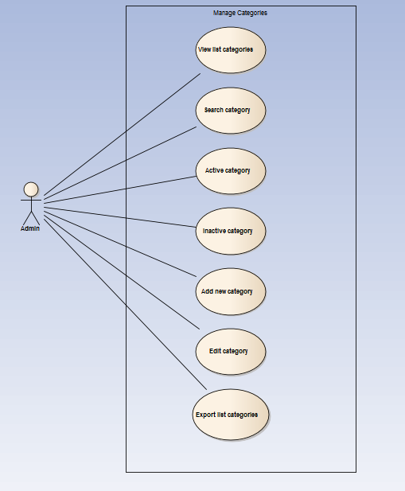

##### UC055- View category list

|  |  |  |  |  |
| --- | --- | --- | --- | --- |
| **Use Case ID** | | UC055 | **Version** | 1.1 |
| **Use Case Name** | | View category list | | |
| **Created by:** | | MaiCTP | **Date Created:** | 28/09/2015 |
| **Primary Actor** | | Administrator(Admin) | **Secondary Actor** |  |
| **Description:** | | This function allows Administrator to view Category list of the project | | |
| **Preconditions:** | | 1. DDL website is available 2. Admin browsed DDL website 3. Admin logged in as Administrator | | |
| **Trigger:** | | Admin clicks on Category | | |
| **Post conditions:** | | Category List is displayed | | |
| **Normal Flow** | | | | |
| **Step** | **Actor** | **Action** | | |
| 1 | Admin | Click on Category at left side | | |
| 2 | DDL | Display list of categories | | |
| **Alternative Flows:** | | | | |

|  |  |  |
| --- | --- | --- |
| **AT1** | At step 1 in the main flows, if do not have any category | |
| **Step** | **Actor** | **Action** |
| 2.1 | DDL | Display “Do not have any category” message |
|  | | |

|  |  |
| --- | --- |
| **Exceptions: N/A** | |
| **Priority** | High |
| **Frequency of Use:** | High |
| **Business Rules:** | B1 |
| **Other Information:** | N/A |

##### UC056- Search category

|  |  |  |  |  |
| --- | --- | --- | --- | --- |
| **Use Case ID** | | UC056 | **Version** | 1.1 |
| **Use Case Name** | | Search category | | |
| **Created by:** | | MaiCTP | **Date Created:** | 28/09/2015 |
| **Primary Actor** | | Administrator(Admin) | **Secondary Actor** |  |
| **Description:** | | This function allows Administrator to search a category | | |
| **Preconditions:** | | Admin is viewing Category List | | |
| **Trigger:** | | Admin types name of category at Search textbox | | |
| **Post conditions:** | | Display list of searched category | | |
| **Normal Flow** | | | | |
| **Step** | **Actor** | **Action** | | |
| 1 | Admin | Type name of category which want to search | | |
| 2 | DDL | Display list of categories which have the name is typed | | |
| **Alternative Flows:** | | | | |

|  |  |  |
| --- | --- | --- |
| **AT1** | At step 1 in the main flows, if the typed name is not exist | |
| **Step** | **Actor** | **Action** |
| 2.1 | DDL | Display “No matching records found” message |
|  | | |

|  |  |
| --- | --- |
| **Exceptions: N/A** | |
| **Priority** | High |
| **Frequency of Use:** | High |
| **Business Rules:** | B1 |
| **Other Information:** | N/A |

##### UC057- Activate category

|  |  |  |  |  |
| --- | --- | --- | --- | --- |
| **Use Case ID** | | UC057 | **Version** | 1.1 |
| **Use Case Name** | | Activate category | | |
| **Created by:** | | MaiCTP | **Date Created:** | 28/09/2015 |
| **Primary Actor** | | Administrator(Admin) | **Secondary Actor** |  |
| **Description:** | | This function allows Administrator to activate a category | | |
| **Preconditions:** | | * Admin is viewing Category List * Status of this category is deactivate | | |
| **Trigger:** | | Admin clicks on Deactivate button | | |
| **Post conditions:** | | Category is activated | | |
| **Normal Flow** | | | | |
| **Step** | **Actor** | **Action** | | |
| 1 | Admin | Click on Deactivate button at Status column of the category which want to activate | | |
| 2 | DDL | * Change displayed status from Deactivate to Activate * Change status of this category to Activate on database | | |
| **Alternative Flows: N/A** | | | | |
| **Exceptions: N/A** | | | | |
| **Priority** | | High | | |
| **Frequency of Use:** | | High | | |
| **Business Rules:** | | B1 | | |
| **Other Information:** | | N/A | | |

##### UC058- Deactivate category

|  |  |  |  |  |
| --- | --- | --- | --- | --- |
| **Use Case ID** | | UC058 | **Version** | 1.1 |
| **Use Case Name** | | Deactivate category | | |
| **Created by:** | | MaiCTP | **Date Created:** | 28/09/2015 |
| **Primary Actor** | | Administrator(Admin) | **Secondary Actor** |  |
| **Description:** | | This function allows Administrator to deactivate a category | | |
| **Preconditions:** | | * Admin is viewing Category List * Status of this category is activate | | |
| **Trigger:** | | Admin clicks on Activate button | | |
| **Post conditions:** | | Category is deactivated | | |
| **Normal Flow** | | | | |
| **Step** | **Actor** | **Action** | | |
| 1 | Admin | Click on Activate button at Status column of the category which want to deactivate | | |
| 2 | DDL | * Change displayed status from Activate to Deactivate * Change status of this category to Deactivate on database | | |
| **Alternative Flows: N/A** | | | | |
| **Exceptions: N/A** | | | | |
| **Priority** | | High | | |
| **Frequency of Use:** | | High | | |
| **Business Rules:** | | B1 | | |
| **Other Information:** | | N/A | | |

##### UC059- Add new category

|  |  |  |  |  |
| --- | --- | --- | --- | --- |
| **Use Case ID** | | UC059 | **Version** | 1.1 |
| **Use Case Name** | | Add new category | | |
| **Created by:** | | MaiCTP | **Date Created:** | 28/09/2015 |
| **Primary Actor** | | Administrator(Admin) | **Secondary Actor** |  |
| **Description:** | | This function allows Administrator to add new a category | | |
| **Preconditions:** | | Admin is viewing Category List | | |
| **Trigger:** | | Admin clicks on Add button | | |
| **Post conditions:** | | New category is added | | |
| **Normal Flow** | | | | |
| **Step** | **Actor** | **Action** | | |
| 1 | Admin | Click on Add Category button at right side of Category list table | | |
| 2 | DDL | Display Add new category popup | | |
| 3 | Admin | * Type Category Name * Type Description * Choose picture from Admin’s computer * Click Add button | | |
| **Alternative Flows:** | | | | |

|  |  |  |
| --- | --- | --- |
| **AT1** | At step 3 in the main flows, if Admin click on Close button | |
| **Step** | **Actor** | **Action** |
| 3.1 | DDL | Turn off Add new category popup |
|  | | |

|  |
| --- |
| **Exceptions:** |

|  |  |  |
| --- | --- | --- |
| **EC1** | At step 4 in main flow, if Admin does not type Category Name/ Description or does not choose picture | |
| **Step** | **Actor** | **Action** |
| 3.1 | DDL | Display Add popup message with error message |
| 3.2 | DDL | Mark error fields |
|  | | |

|  |  |
| --- | --- |
| **Priority** | High |
| **Frequency of Use:** | High |
| **Business Rules:** | B1 |
| **Other Information:** | N/A |

##### UC060- Edit category

|  |  |  |  |  |
| --- | --- | --- | --- | --- |
| **Use Case ID** | | UC060 | **Version** | 1.1 |
| **Use Case Name** | | Edit category | | |
| **Created by:** | | MaiCTP | **Date Created:** | 28/09/2015 |
| **Primary Actor** | | Administrator(Admin) | **Secondary Actor** |  |
| **Description:** | | This function allows Administrator to edit a category | | |
| **Preconditions:** | | Admin is viewing Category List | | |
| **Trigger:** | | Admin clicks on Edit button | | |
| **Post conditions:** | | Category is edited | | |
| **Normal Flow** | | | | |
| **Step** | **Actor** | **Action** | | |
| 1 | Admin | Click on Edit button at Edit column | | |
| 2 | DDL | Display Edit category popup | | |
| 3 | Admin | * Type Category Name * Type Description * Choose picture from Admin’s computer * Click Add button | | |
| **Alternative Flows:** | | | | |

|  |  |  |
| --- | --- | --- |
| **AT1** | At step 3 in the main flows, if Admin click on Close button | |
| **Step** | **Actor** | **Action** |
| 3.1 | DDL | * Turn off Edit category popup * Keep old information of this category |
|  | | |

|  |  |
| --- | --- |
| **Exceptions: N/A** | |
| **Priority** | High |
| **Frequency of Use:** | High |
| **Business Rules:** | B1 |
| **Other Information:** | N/A |

##### UC061- Export category list

|  |  |  |  |  |
| --- | --- | --- | --- | --- |
| **Use Case ID** | | UC061 | **Version** | 1.1 |
| **Use Case Name** | | Export category list | | |
| **Created by:** | | MaiCTP | **Date Created:** | 28/09/2015 |
| **Primary Actor** | | Administrator(Admin) | **Secondary Actor** |  |
| **Description:** | | This function allows Administrator to export list of category | | |
| **Preconditions:** | | Admin is viewing Category List | | |
| **Trigger:** | | Admin clicks on Export button | | |
| **Post conditions:** | | List of categories is exported | | |
| **Normal Flow** | | | | |
| **Step** | **Actor** | **Action** | | |
| 1 | Admin | Click on Export button at right side Category list table | | |
| 2 | DDL | Export list of categories to file | | |
| **Alternative Flows: N/A** | | | | |
| **Exceptions: N/A** | | | | |
| **Priority** | | High | | |
| **Frequency of Use:** | | High | | |
| **Business Rules:** | | B1 | | |
| **Other Information:** | | N/A | | |

#### Manage Sliders

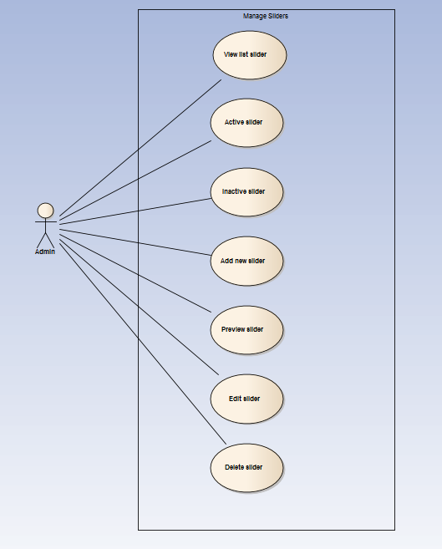

##### UC062- View slider list

|  |  |  |  |  |
| --- | --- | --- | --- | --- |
| **Use Case ID** | | UC062 | **Version** | 1.1 |
| **Use Case Name** | | View slider list | | |
| **Created by:** | | MaiCTP | **Date Created:** | 28/09/2015 |
| **Primary Actor** | | Administrator(Admin) | **Secondary Actor** |  |
| **Description:** | | This function allows Administrator to view Slider list of the project | | |
| **Preconditions:** | | 1. DDL website is available 2. Admin browsed DDL website 3. Admin logged in as Administrator | | |
| **Trigger:** | | Admin clicks on Slider | | |
| **Post conditions:** | | Slider List is displayed | | |
| **Normal Flow** | | | | |
| **Step** | **Actor** | **Action** | | |
| 1 | Admin | Click on Slider at left side | | |
| 2 | DDL | Display list of sliders | | |
| **Alternative Flows:** | | | | |

|  |  |  |
| --- | --- | --- |
| **AT1** | At step 1 in the main flows, if do not have any slider | |
| **Step** | **Actor** | **Action** |
| 2.1 | DDL | Display “Do not have any slider” message |
|  | | |

|  |  |
| --- | --- |
| **Exceptions: N/A** | |
| **Priority** | High |
| **Frequency of Use:** | High |
| **Business Rules:** | B1 |
| **Other Information:** | N/A |

##### UC063- Active slider

|  |  |  |  |  |
| --- | --- | --- | --- | --- |
| **Use Case ID** | | UC063 | **Version** | 1.1 |
| **Use Case Name** | | Active slider | | |
| **Created by:** | | MaiCTP | **Date Created:** | 28/09/2015 |
| **Primary Actor** | | Administrator(Admin) | **Secondary Actor** |  |
| **Description:** | | This function allows Administrator to activate a slider | | |
| **Preconditions:** | | * Admin is viewing Slider List * Status of this slider is deactivate | | |
| **Trigger:** | | Admin clicks on Deactivate button | | |
| **Post conditions:** | | Slider is activated | | |
| **Normal Flow** | | | | |
| **Step** | **Actor** | **Action** | | |
| 1 | Admin | Click on Deactivate button at Status column of the slider which want to activate | | |
| 2 | DDL | * Change displayed status from Deactivate to Activate * Change status of this slider to Activate on database | | |
| **Alternative Flows: N/A** | | | | |
| **Exceptions: N/A** | | | | |
| **Priority** | | High | | |
| **Frequency of Use:** | | High | | |
| **Business Rules:** | | B1 | | |
| **Other Information:** | | N/A | | |

##### UC064- Deactivate slider

|  |  |  |  |  |
| --- | --- | --- | --- | --- |
| **Use Case ID** | | UC064 | **Version** | 1.1 |
| **Use Case Name** | | Deactivate slider | | |
| **Created by:** | | MaiCTP | **Date Created:** | 28/09/2015 |
| **Primary Actor** | | Administrator(Admin) | **Secondary Actor** |  |
| **Description:** | | This function allows Administrator to deactivate a slider | | |
| **Preconditions:** | | * Admin is viewing Slider List * Status of this slider is activate | | |
| **Trigger:** | | Admin clicks on Activate button | | |
| **Post conditions:** | | Slider is deactivated | | |
| **Normal Flow** | | | | |
| **Step** | **Actor** | **Action** | | |
| 1 | Admin | Click on Activate button at Status column of the slider which want to deactivate | | |
| 2 | DDL | * Change displayed status from Activate to Deactivate * Change status of this slider to Deactivate on database | | |
| **Alternative Flows: N/A** | | | | |
| **Exceptions: N/A** | | | | |
| **Priority** | | High | | |
| **Frequency of Use:** | | High | | |
| **Business Rules:** | | B1 | | |
| **Other Information:** | | N/A | | |

##### UC065- Add new slider

|  |  |  |  |  |
| --- | --- | --- | --- | --- |
| **Use Case ID** | | UC065 | **Version** | 1.1 |
| **Use Case Name** | | Add new slider | | |
| **Created by:** | | MaiCTP | **Date Created:** | 28/09/2015 |
| **Primary Actor** | | Administrator(Admin) | **Secondary Actor** |  |
| **Description:** | | This function allows Administrator to add new a slider | | |
| **Preconditions:** | | Admin is viewing Slider List | | |
| **Trigger:** | | Admin clicks on Add button | | |
| **Post conditions:** | | New slider is added | | |
| **Normal Flow** | | | | |
| **Step** | **Actor** | **Action** | | |
| 1 | Admin | Click on Add Slider button at right side of Slider list table | | |
| 2 | DDL | Display Add new slider popup | | |
| 3 | Admin | * Type Slider Title * Type Slider Description * Type Slider Url * Choose picture from Admin’s computer * Choose Button Color * Choose Slider Order * Choose status * Click Add button | | |
| **Alternative Flows:** | | | | |

|  |  |  |
| --- | --- | --- |
| **AT1** | At step 3 in the main flows, if Admin click on Close button | |
| **Step** | **Actor** | **Action** |
| 3.1 | DDL | Turn off Add new slider popup |
|  | | |

|  |
| --- |
| **Exceptions:** |

|  |  |  |
| --- | --- | --- |
| **EC1** | * At step 3 in main flow, if Admin does not type Slider Title/ Slider Description/ Slider Url or does not choose picture/ Button Color/ Slider Order/ status | |
| **Step** | **Actor** | **Action** |
| 3.1 | DDL | Display Add popup message with error message |
| 3.2 | DDL | Mark error fields |
|  | | |

|  |  |
| --- | --- |
| **Priority** | High |
| **Frequency of Use:** | High |
| **Business Rules:** | B1 |
| **Other Information:** | N/A |

##### UC066- Preview slider

|  |  |  |  |  |
| --- | --- | --- | --- | --- |
| **Use Case ID** | | UC066 | **Version** | 1.1 |
| **Use Case Name** | | Preview slider | | |
| **Created by:** | | MaiCTP | **Date Created:** | 28/09/2015 |
| **Primary Actor** | | Administrator(Admin) | **Secondary Actor** |  |
| **Description:** | | This function allows Administrator to preview slider | | |
| **Preconditions:** | | Admin is viewing Slider List | | |
| **Trigger:** | | Admin clicks on Preview button at Action column | | |
| **Post conditions:** | | Preview of this slider is displayed | | |
| **Normal Flow** | | | | |
| **Step** | **Actor** | **Action** | | |
| 1 | Admin | Admin clicks on Preview button at Action column of the slider which want to preview | | |
| 2 | DDL | Display preview of this slider | | |
| **Alternative Flows: N/A** | | | | |
| **Exceptions: N/A** | | | | |
| **Priority** | | High | | |
| **Frequency of Use:** | | High | | |
| **Business Rules:** | | B1 | | |
| **Other Information:** | | N/A | | |

##### UC067- Edit slider

|  |  |  |  |  |
| --- | --- | --- | --- | --- |
| **Use Case ID** | | UC067 | **Version** | 1.1 |
| **Use Case Name** | | Edit slider | | |
| **Created by:** | | MaiCTP | **Date Created:** | 28/09/2015 |
| **Primary Actor** | | Administrator(Admin) | **Secondary Actor** |  |
| **Description:** | | This function allows Administrator to edit a slider | | |
| **Preconditions:** | | Admin is viewing Slider List | | |
| **Trigger:** | | Admin clicks on Edit button | | |
| **Post conditions:** | | Slider edited | | |
| **Normal Flow** | | | | |
| **Step** | **Actor** | **Action** | | |
| 1 | Admin | Click on Edit button at Action column | | |
| 2 | DDL | Display Edit slider popup | | |
| 3 | Admin | Type all needed information | | |
| **Alternative Flows:** | | | | |

|  |  |  |
| --- | --- | --- |
| **AT1** | At step 3 in the main flows, if Admin click on Close button | |
| **Step** | **Actor** | **Action** |
| 3.1 | DDL | * Turn off Edit slider popup * Keep old information of this slider |
|  | | |

|  |  |
| --- | --- |
| **Exceptions: N/A** | |
| **Priority** | High |
| **Frequency of Use:** | High |
| **Business Rules:** | B1 |
| **Other Information:** | N/A |

##### UC068- Delete slider

|  |  |  |  |  |
| --- | --- | --- | --- | --- |
| **Use Case ID** | | UC068 | **Version** | 1.1 |
| **Use Case Name** | | Delete slider | | |
| **Created by:** | | MaiCTP | **Date Created:** | 28/09/2015 |
| **Primary Actor** | | Administrator(Admin) | **Secondary Actor** |  |
| **Description:** | | This function allows Administrator to delete a slider | | |
| **Preconditions:** | | Admin is viewing Slider List | | |
| **Trigger:** | | Admin clicks on Delete button | | |
| **Post conditions:** | | Slider deleted | | |
| **Normal Flow** | | | | |
| **Step** | **Actor** | **Action** | | |
| 1 | Admin | Click on Delete button at Action column | | |
| 2 | DDL | Display Deleted confirm popup | | |
| 3 | Admin | Click on Delete button | | |
| **Alternative Flows:** | | | | |

|  |  |  |
| --- | --- | --- |
| **AT1** | At step 3 in the main flows, if Admin click on Close button | |
| **Step** | **Actor** | **Action** |
| 3.1 | DDL | * Turn off Delete slider popup * Keep all information of this slider |
|  | | |

|  |  |
| --- | --- |
| **Exceptions: N/A** | |
| **Priority** | High |
| **Frequency of Use:** | High |
| **Business Rules:** | B1 |
| **Other Information:** | N/A |

#### Manage Message

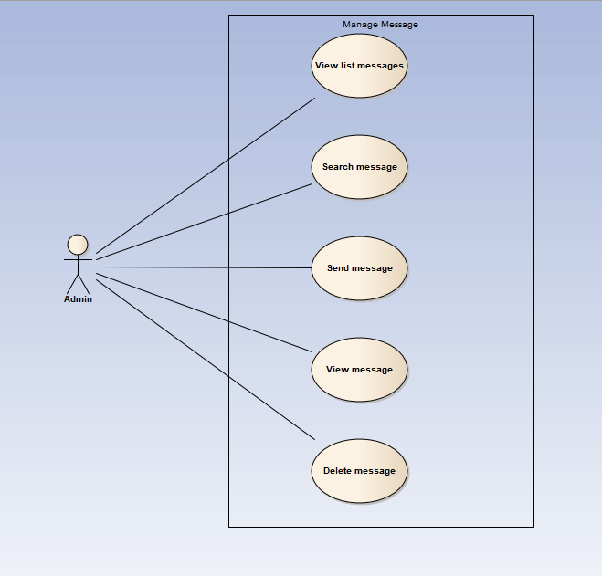

##### UC069- View message list

|  |  |  |  |  |
| --- | --- | --- | --- | --- |
| **Use Case ID** | | UC069 | **Version** | 1.1 |
| **Use Case Name** | | View message list | | |
| **Created by:** | | MaiCTP | **Date Created:** | 28/09/2015 |
| **Primary Actor** | | Administrator(Admin) | **Secondary Actor** |  |
| **Description:** | | This function allows Administrator to view Message list of the project | | |
| **Preconditions:** | | 1. DDL website is available 2. Admin browsed DDL website 3. Admin logged in as Administrator | | |
| **Trigger:** | | Admin clicks on Message | | |
| **Post conditions:** | | Message List is displayed | | |
| **Normal Flow** | | | | |
| **Step** | **Actor** | **Action** | | |
| 1 | Admin | Click on Message at left side | | |
| 2 | DDL | Display list of messages | | |
| **Alternative Flows: N/A** | | | | |
| **Exceptions: N/A** | | | | |
| **Priority** | | High | | |
| **Frequency of Use:** | | High | | |
| **Business Rules:** | | B1 | | |
| **Other Information:** | | N/A | | |

##### UC070- Search message

|  |  |  |  |  |
| --- | --- | --- | --- | --- |
| **Use Case ID** | | UC070 | **Version** | 1.1 |
| **Use Case Name** | | Search message | | |
| **Created by:** | | MaiCTP | **Date Created:** | 28/09/2015 |
| **Primary Actor** | | Administrator(Admin) | **Secondary Actor** |  |
| **Description:** | | This function allows Administrator to search a message | | |
| **Preconditions:** | | Admin is viewing Message List | | |
| **Trigger:** | | Admin clicks on Search button | | |
| **Post conditions:** | | Display list of searched message | | |
| **Normal Flow** | | | | |
| **Step** | **Actor** | **Action** | | |
| 1 | Admin | * Type name of category which want to search * Click on Search button | | |
| 2 | DDL | Display list of messages which have the name is typed | | |
| **Alternative Flows: N/A** | | | | |
| **Exceptions:** | | | | |

|  |  |  |
| --- | --- | --- |
| **AT1** | At step 1 in the main flows, if the typed name is not exist | |
| **Step** | **Actor** | **Action** |
| 2.1 | DDL | Display “No matching records found” message |
|  | | |

|  |  |
| --- | --- |
| **Priority** | High |

##### UC071- Send message

|  |  |  |  |  |
| --- | --- | --- | --- | --- |
| **Use Case ID** | | UC071 | **Version** | 1.1 |
| **Use Case Name** | | Send message | | |
| **Created by:** | | MaiCTP | **Date Created:** | 28/09/2015 |
| **Primary Actor** | | Administrator(Admin) | **Secondary Actor** |  |
| **Description:** | | This function allows Administrator to send a message | | |
| **Preconditions:** | | Admin is viewing Message List | | |
| **Trigger:** | | Admin clicks on Send button | | |
| **Post conditions:** | | Message is send | | |
| **Normal Flow** | | | | |
| **Step** | **Actor** | **Action** | | |
| 1 | Admin | Click on New message button | | |
| 2 | DDL | Display Send Message popup | | |
| 3 | Admin | * Type all needed information at popup * Click on Send button | | |
| 4 | DDL | Send message to To email address | | |
| **Alternative Flows:** | | | | |

|  |  |  |
| --- | --- | --- |
| **AT1** | At step 3 in the main flows, if Admin click on Close button | |
| **Step** | **Actor** | **Action** |
| 3.1 | DDL | * Close Send Message popup |
|  | | |

|  |  |
| --- | --- |
| **Exceptions: N/A** | |
| **Priority** | High |

##### UC072- View message

|  |  |  |  |  |
| --- | --- | --- | --- | --- |
| **Use Case ID** | | UC072 | **Version** | 1.1 |
| **Use Case Name** | | View message | | |
| **Created by:** | | MaiCTP | **Date Created:** | 28/09/2015 |
| **Primary Actor** | | Administrator(Admin) | **Secondary Actor** |  |
| **Description:** | | This function allows Administrator to view a message | | |
| **Preconditions:** | | Admin is viewing Message List | | |
| **Trigger:** | | Admin clicks on a message | | |
| **Post conditions:** | | Message is viewed | | |
| **Normal Flow** | | | | |
| **Step** | **Actor** | **Action** | | |
| 1 | Admin | Click on a message | | |
| 2 | DDL | Display View Message popup | | |
| **Alternative Flows: N/A** | | | | |
| **Exceptions: N/A** | | | | |
| **Priority** | | High | | |

##### UC073- Delete message

|  |  |  |  |  |
| --- | --- | --- | --- | --- |
| **Use Case ID** | | UC073 | **Version** | 1.1 |
| **Use Case Name** | | Delete message | | |
| **Created by:** | | MaiCTP | **Date Created:** | 28/09/2015 |
| **Primary Actor** | | Administrator(Admin) | **Secondary Actor** |  |
| **Description:** | | This function allows Administrator to delete a message | | |
| **Preconditions:** | | Admin is viewing Message List | | |
| **Trigger:** | | Admin clicks on Delete button | | |
| **Post conditions:** | | Message deleted | | |
| **Normal Flow** | | | | |
| **Step** | **Actor** | **Action** | | |
| 1 | Admin | Click on checkbox in front of message which want to delete | | |
| 2 | DDL | Display Deleted confirm popup | | |
| 3 | Admin | Click on Delete button | | |
| **Alternative Flows:** | | | | |

|  |  |  |
| --- | --- | --- |
| **AT1** | At step 3 in the main flows, if Admin click on Close button | |
| **Step** | **Actor** | **Action** |
| 3.1 | DDL | * Turn off Delete message popup * Keep all information of this message |
|  | | |

|  |  |
| --- | --- |
| **Exceptions: N/A** | |
| **Priority** | High |
| **Frequency of Use:** | High |
| **Business Rules:** | B1 |
| **Other Information:** | N/A |

#### Manage Report

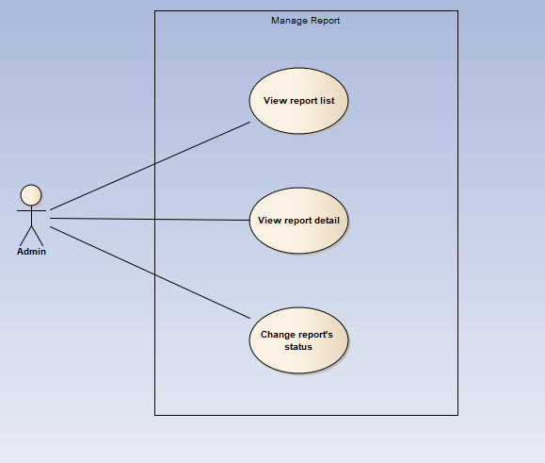

##### UC074- View report list

|  |  |  |  |  |
| --- | --- | --- | --- | --- |
| **Use Case ID** | | UC074 | **Version** | 1.1 |
| **Use Case Name** | | View report list | | |
| **Created by:** | | MaiCTP | **Date Created:** | 28/09/2015 |
| **Primary Actor** | | Administrator(Admin) | **Secondary Actor** |  |
| **Description:** | | This function allows Administrator to view Report list of the project | | |
| **Preconditions:** | | 1. DDL website is available 2. Admin browsed DDL website 3. Admin logged in as Administrator | | |
| **Trigger:** | | Admin clicks on User/ Project | | |
| **Post conditions:** | | Report List is displayed | | |
| **Normal Flow** | | | | |
| **Step** | **Actor** | **Action** | | |
| 1 | Admin | * Click on Report at left side * Click on User/ Project | | |
| 2 | DDL | Display list of reports | | |
| **Alternative Flows: N/A** | | | | |
| **Exceptions: N/A** | | | | |
| **Priority** | | High | | |
| **Frequency of Use:** | | High | | |
| **Business Rules:** | | B1 | | |
| **Other Information:** | | N/A | | |

##### UC075- View report detail

|  |  |  |  |  |
| --- | --- | --- | --- | --- |
| **Use Case ID** | | UC075 | **Version** | 1.1 |
| **Use Case Name** | | View report detail | | |
| **Created by:** | | MaiCTP | **Date Created:** | 28/09/2015 |
| **Primary Actor** | | Administrator(Admin) | **Secondary Actor** |  |
| **Description:** | | This function allows Administrator to view information of a report | | |
| **Preconditions:** | | Admin is viewing Report List | | |
| **Trigger:** | | Admin clicks on button View at Action column | | |
| **Post conditions:** | | Detail of this report is displayed | | |
| **Normal Flow** | | | | |
| **Step** | **Actor** | **Action** | | |
| 1 | Admin | Admin clicks on button View at Action column of the user/ project which want to view report’s detail information | | |
| 2 | DDL | Display View Report Content popup | | |
| **Alternative Flows: N/A** | | | | |
| **Exceptions: N/A** | | | | |
| **Priority** | | High | | |
| **Frequency of Use:** | | High | | |
| **Business Rules:** | | B1 | | |
| **Other Information:** | | N/A | | |

##### UC076- Change report's status

|  |  |  |  |  |
| --- | --- | --- | --- | --- |
| **Use Case ID** | | UC076 | **Version** | 1.1 |
| **Use Case Name** | | Change report's status | | |
| **Created by:** | | MaiCTP | **Date Created:** | 28/09/2015 |
| **Primary Actor** | | Administrator(Admin) | **Secondary Actor** |  |
| **Description:** | | This function allows Administrator to change status of a report | | |
| **Preconditions:** | | Admin is viewing Report List | | |
| **Trigger:** | | Admin clicks on button at Status column | | |
| **Post conditions:** | | Status of this report is changed | | |
| **Normal Flow** | | | | |
| **Step** | **Actor** | **Action** | | |
| 1 | Admin | Admin clicks on button Waiting/ Cancel/ Confirmed at Status column of the user/ project which want to change report’s status | | |
| 2 | DDL | * Display changed status as content of the button * Change status of report in database | | |
| **Alternative Flows: N/A** | | | | |
| **Exceptions: N/A** | | | | |
| **Priority** | | High | | |
| **Frequency of Use:** | | High | | |
| **Business Rules:** | | B1 | | |
| **Other Information:** | | N/A | | |

# **NON-FUNCTIONAL SPECIFICATION**

### Reliability

1. Mean time between failures: The mean time between each failure is expected to be about 480 hours of using.
2. The maximum bugs per function are 2 bugs/a function when user uses software within 2 months. The average number of bugs in the software during system testing is about to be around 1 bugs/KLOC.
3. The database must be backed up daily and can be recovered if necessary

### Performance Requirements

#### Availability

The application must be available 95% of time. Users can access to it everywhere from their

Web browser with internet connection.

#### Response time

In term of response time, waiting time of processing will be 2 to 5 seconds; time to process any functions will not exceed 7 seconds.

#### Maintainability

* **Coding standards and naming conventions**
  + Output of the project must include coding standards and naming conventions documentations. Implementation code must be easy to maintain.
  + If some components are reused, the documentations of those components must also be included.
* **Design**
  + The design of the system must be loosely coupled that chances on some module will not affect others.
* **Logging**
  + All the errors should be logged, supporting for bug fixing and maintenance.
  + All strange or sensitive situations should also be logged.
* **Mean time to repair:** Immediately when Administrator finds out problem or website is attacked/ hacked by someone. Average 1 day.

#### Usability

Usability Requirements support the following from the perspective of its primary users:

● **Efficiency of use:** user can complete each function in less than 12 actions

● **Intuitiveness:** User can understand approximately 90% help/ error messages

#### Security Requirements

In order to avoid unwanted access by strangers, the security implemented in various ways:

1. **User authorize**: Each function must be distributed system access and manipulate the individual parts. To edit information, user must declare their username and password before the operation. Functions will be show after users login dependencies user’s role and permission of each user.
2. **Manage Data Layer**: Only Administrator can modify database system.

#### Hardware/Software Requirements

● **Hardware requirement:**

**- Server:** Web service 2013, IIS7

**- Client:** PC/Laptop (window 7, window 8)

● **Software requirements:** Web browser (Chrome 40.0, Firefox 30.0) with internet connection